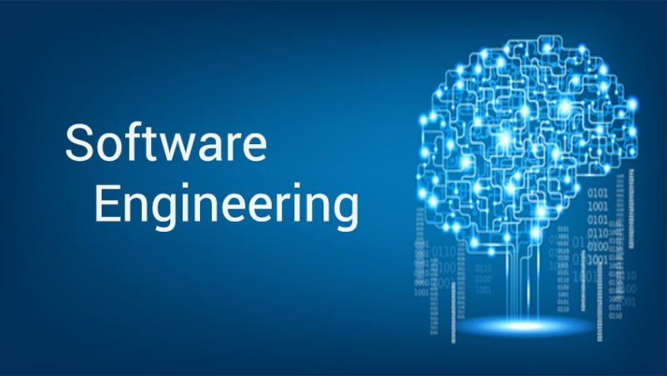

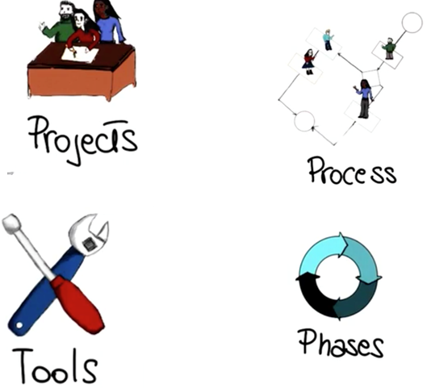

**What is software?**

**Software is instructions (computer programs) that when executed provide desired function and performance,**

Software is data structures that enable the programs to adequately manipulate information, and

Software is documents that describe the operation and use of the programs.

**What is software engineering?**

**Software engineering is an engineering discipline that is concerned with all aspects of software production**

**IEEE Definition** The **application of a systematic, disciplined, quantifiable approach to the development, operation, and maintenance of software.**

**Why do we need it?**

**Objectives of Software Engineering:**

* To improve quality of software products
* To increase customer satisfaction
* To increase productivity
* To increase job satisfaction
* Software engineering is not programming. Programming is an important part of software engineering.

**Why is it so hard to build software ?**

**Why is it so hard to build good software?**

**Discipline of Software Engineering**

This is exactly the topic of this class. And the reason why software engineering is a fundamental discipline in computer science. To motivate that, in this class, we will study a set of methodologies, techniques, and tools, that will help us build high quality software that does what it's supposed to do.

And therefore, makes our customers happy. And that does it within the given time and money constraints.

So within the budget that is allocated for the software. Before jumping into today's software engineering techniques though, let me take a step back and look at how we got here, as I believe it is very important to have some historical perspective on how this discipline was born and how it was developed over the years.

**Discipline of Software Engineering**

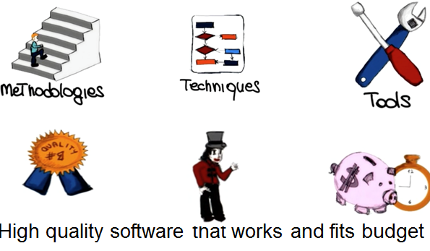

**The software crisis.**

**Rising Demand for Software**

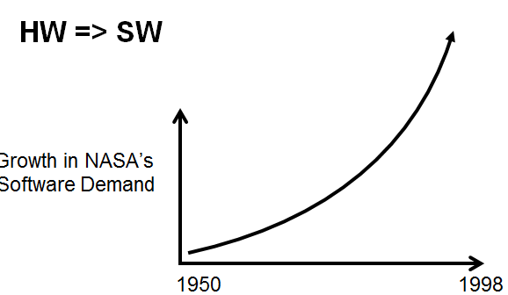

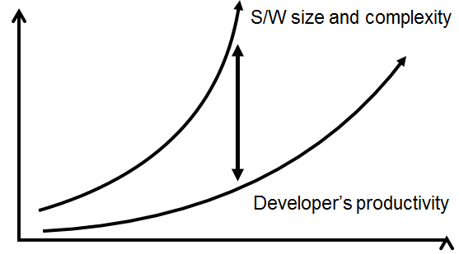

**Developers Productivity Growth**

**So let’s look at some of the most important reasons behind this crisis.**

**What are the major causes of the software crisis?**

* Increasing cost of Computers
* **Increasing product complexity**
* Lack of programmers
* **Slow programmer’s productivity growth**
* Lack of funding for software engineering research
* **Rising demand for software**
* Lack of caffeine in software development organizations

Definitely one of the causes was the increasing product complexity.

Products were becoming more and more complex and software was replacing more and more, what was before, provided by hardware components.

**Slow productivity growth was another problem**, because programmers could not keep up with the additional complexity of the software that they had to develop.

I would like to say there was lack of funding for software engineering research because I’m a software engineering researcher, but that was not one of the reasons for the software crisis. Instead, it was **the rising demand for software**.

Again, more and more software was being required and more and more software was replacing hardware.

**Way of Software Development:**

**Software Process**

* Systematic
* Formal

Now that we saw how software engineering was born and we saw some of the problems that led to the birth of software engineering.

Let's see how we can do better. How can we preform software development in a smarter, in a better way, a more successful way?

So what I'm going to show here is the way I see software development. To me software development is fundamentally going from an abstract idea in somebody's head, for example, the customer's head, to a concrete system that actually implements that idea and hopefully it does it in the right way. And this is a very complex process. It can be overwhelming. So, unless we are talking about the trivial system, it's very complex for us to keep in mind all the different aspects of the systems, and to do all the different steps required to build this system, automatically. So that's when software processes come to the rescue. So what is a software process?

A software process is nothing else but a way of breaking down this otherwise unmanageable task into smaller steps. In smaller steps that we can handle. And that can be tackled individually.

**So having a software process is of fundamental importance for several reasons**.

* First of all, for non-trivial systems, you can't just do it by getting it, by just sitting down and developing. What you have to do instead is to break down the complexity in a systematic way. So software processes are normally systematic.
* And you need to break down this complexity, in a more or less formal way.
* So software processes are also a formal, or semiformal, way of discussing, or describing, how software should be developed.

So what are the steps involved in developing software?

* One thing you need to know right away about software processes is that there's not just one single process, but there are multiple, possible processes, depending on your context, depending on the kind of applications that you are developing.
* In this course, we are going to try to cover the spectrum of the possible processes, as much as possible, by focusing on four main software processes.
* The first one is what we call normally the waterfall process. And, we call it waterfall because in the process we go from one phase to the other in the same way in which water follows the flow in a waterfall.
* The second process that we consider is what we call evolutionary prototyping, and in this case, instead of following this set of rigid steps, all we're trying to do is to start with an initial prototype and evolve it based on the feedback from the customer.
* We will then move towards a slightly more formal process, which is the rational unified process or the unified software process. And this is a kind of project heavily based on the use of UML, so we will also cover UML when discussing this kind of project.
* Finally, the fourth kind of process we will consider is the family of agile software processes. And these are processes in which we sacrifice the discipline a little bit in order to be more flexible and be more able to account for changes and in particular for changes in requirements. We are going to cover each one of these four processes extensively in the rest of the class.

**Questions:**

**What is the largest software system on which you have worked?**

**How many LOC/day were you producing?**

* So, now before we actually jump to the discussion of software processes I want to ask you a couple of preliminary questions.
* The first one is, what is the largest software system on which you had worked? And you should enter here the size.
* And the second question I'm going to ask is how many LOC or how many lines of code per day you were producing when working on this system?

So now I want to ask you one additional question, which is how many lines of code a day do you think professional software engineers produce?

Do you think they produce 25 lines of code?

* Between 25 and 50?
* Between 50 and 100?
* Between 100 and 1000?
* Or more than 1000 a day? And remember that here we're talking about professional software engineers.
* Studies has shown that, on average, developers produce between 50 and 100 lines of code a day.
* And that might not seem much.
* Why, why only 50 to 100 lines of code in a whole day?
* And the answer is because coding is not everything.
* When you develop a system writing code is not the only thing you have to do. It's not the only activity that you have to perform.
* And that's a very important point.

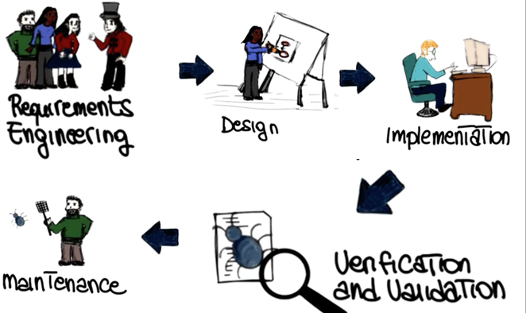

**Software Phases:**

In fact, software processes are normally characterized by several phases, what we call the software phases, and only one of these phases is mainly focused on coding.

The other phases are meant to support other parts of software development.

The first of these phases is called requirements engineering and that's the phase in which we talk to the customer, to the stakeholders, whoever we are building the software for. And we try to understand what kind of system we need to build.

Then we use this information to define our design and the design is the high-level structure, that then can become more and more detailed, of our software system.

Once we've defined our design we can actually move to the next phase, which is the implementation, in which we write code that implements the design which we just defined.

After implementing the code, we need to verify and validate the code. We need to make sure that the code behaves as intended.

And finally, we need to maintain the code. And maintenance involves several activities like, for example, adding new functionality or eliminating bugs from the code or responding to problems that were reported from the field after we released the software.

We will look at all of these activities and of the software development process in detail, in the rest of the class. And for each activity, we will look at the fundamental principles and how it is done currently. And in some cases, we will also look at some advance ways to do it. For example, more research approaches for that activity.

**Tools of the Trade**

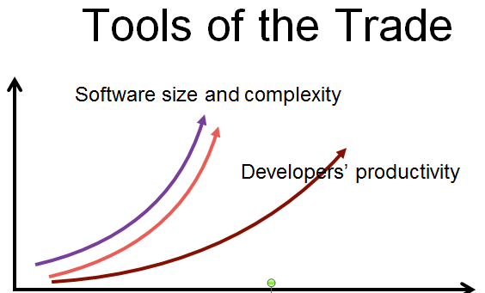

* Development: punch cards - > IDEs
* Language: Machine code -> High-Level Languages
* Debugging: Print lines -> Symbolic DEBUGGERS
* We will also look at how tools can improve software phases, the software activities, and can support software development tasks in general. And this is something that I will repeat over and over in the class, tools and automation are fundamental, in software engineering.
* And they're fundamental for improving productivity, not only efficiency but also effectiveness of our activities in the software development process.
* So let me go back to one of the diagrams that I showed you before. If you remember we had this qualitative diagram in which we were showing that one of the issues that led to the software crisis was the fact that developers' productivity was not able to keep up with the software size and complexity, with the growth in the importance and the complexity of software.
* What tools can help us to do is to change this and basically move this curve from this original position up here. So that it gets closer and closer to what we need to develop the software that we need to build.
* So let me discuss examples on how tools can improve productivity.
* For example, if we are talking about development, think about what kind of improvement it was to go from punch cards to modern IDEs.
* If we're talking about languages, think about of how much more productive developers became when going from writing machine code to writing code in high-level languages.
* And finally, if we talk about debugging, which is a very important and expensive activity, moving from the use of print lines to the use of symbolic debuggers dramatically improve the effectiveness and efficiency of development.
* 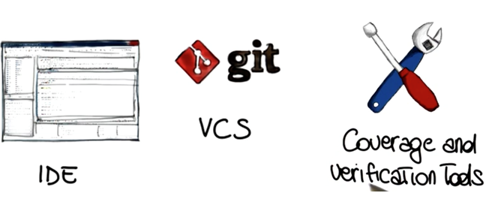And these are just some of the tools that we will discuss in the rest of the class and notice that we will also use the tools in practice. So we will use the tools before projects and also during the lessons and for assignments.
* In particular, we will use three main kinds of tools.
* The first type is IDE's. And I'm pretty sure you're familiar with IDE's. These are integrated development environments. So, advanced editors in which you can write, compile, run, and debug and even test your code.
* We'll also use a version control system, systems that allow you to save, and restore, and check the differences between different versions of the code, in particular we will be working with git.
* We will also be looking at other kinds of tools like coverage and verification tools.
* These are tools that can help you during testing and I'm a big fan of these tools, so I'm really going to stress the usefulness of these tools and how you should use them in your development.

**Software Applications**

* system software
* application software
* engineering/scientific software
* embedded software
* product-line software
* web applications
* AI software

**Software is Manufacturing vs. Development**

* Once a hardware product has been manufactured, it is difficult or impossible to modify. In contrast, software products are routinely modified and upgraded.
* In hardware, hiring more people allows you to accomplish more work, but the same does not necessarily hold true in software engineering.
* Unlike hardware, software costs are concentrated in design rather than production.

**Software Wear vs. Deterioration**

Hardware wears out over time

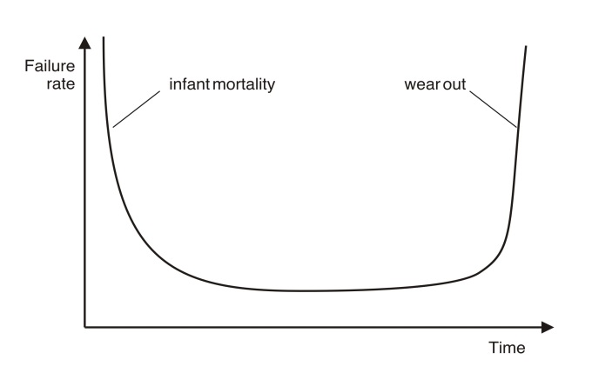

Software deteriorates over time

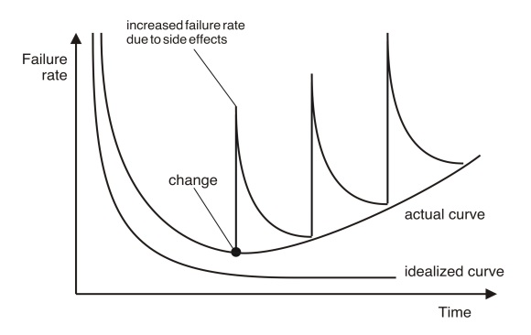

**Legacy Software:**

What is legacy software?

* + Legacy means heritage/ traditional / folklore
  + Any soft. 🡪 one of the 7 categories.
  + Most of them – state-of-the-art
  + Some of them are older- used for decades.
  + Older programs – often called legacy software

**Definition:** Legacy software is software that has been around a long time and still fulfills a business need. It is mission critical and tied to a particular version of an operating system or hardware model (vendor lock-in) that has gone end-of-life. Generally the lifespan of the hardware is shorter than that of the software.

**Why must it change?**

* It must be fixed to eliminate errors.
* It must be enhanced to implement new functional and non-functional requirements
* Software must be adapted to meet the needs of new computing environments or technology.
* Software must be enhanced to implement new business requirements.
* Software must be extended to make it interoperable with other more modern systems or databases.
* Software must be re-architected to make it viable within a network environment.

**Software Myths**

* Myth 🡪 fairy story /legend/ lie
* Affect
  + managers,
  + customers (and other non-technical stakeholders) and
  + practitioners
* Are believable because they often have elements of truth,
* but …
  + Invariably lead to bad decisions,
    - therefore …Insist on reality as you navigate your way through software engineering

**Software Myths**

* If we get behind schedule, we can add more programmers and catch up.
* A general statement about objectives is sufficient to begin building programs.
* Change in project requirements can be easily accommodated because software is flexible.
* Once we write a working program, we’re done.
* Until I get the program running, I have no way of assessing its quality.
* The only deliverable work product for a successful project is the working program.
* Software engineering will make us create too much documentation and will slow us down.

**Management Myths:**

* “We already have a book of standards and procedures for building software. It does provide my people with everything they need to know …”
* “If my project is behind the schedule, I always can add more programmers to it and catch up …”  
   (a.k.a. “**The Mongolian Horde concept**”)
* “If I decide to outsource the software project to a third party, I can just relax: Let them build it, and I will just pocket my profits …”

**Customer Myths:**

* “A general statement of objectives is sufficient to begin writing programs - we can fill in the details later …”
* “Project requirements continually change but this change can easily be accommodated because software is flexible …”

**Practitioner’s Myths:**

* “Let’s start coding ASAP, because once we write the program and get it to work, our job is done …”
* “Until I get the program running, I have no way of assessing its quality …”
* “The only deliverable work product for a successful project is the working program …”
* “Software engineering is baloney. It makes us create tons of paperwork, only to slow us down …”



**What is it?** Software engineering encompasses a process, a collection of methods (practice) and an  
array of tools that allow professionals to build high-quality computer software.

**Who does it?** Software engineers apply the software engineering process.  
**Why is it important?** Software engineering is important because it enables us to build complex systems in a timely manner and with high quality. It imposes discipline to work that can become quite chaotic, but it also allows the people who build computer software to adapt their approach in a manner that best suits their needs.   
**What are the steps?** You build computer software like you build any successful product,  
by applying an agile, adaptable process that leads to a high-quality result that meets the  
needs of the people who will use the product. You apply a software engineering approach.  
**What is the work product?** From the point of view of a software engineer, the work product is the set of programs, content (data), and other work products that are computer software. But from the user’s viewpoint, the work product is the resultant information that somehow makes the user’s world better.  
**How do I ensure that I’ve done it right?** Read the remainder of this book, select those ideas that are applicable to the software that you build, and apply them to your work.

Software Engineering: (1) The application of a systematic, disciplined, quantifiable approach to the development, operation, and maintenance of software; that is, the application of engineering to software. (2) The study of approaches as in (1). - IEEE Standard 610.12-1990

**A Layered Technology:**

**Software Engineering is a Layered Technology**:

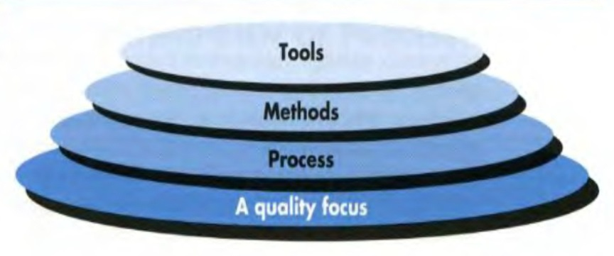

Software engineering is a layered technology. Referring to Figure 2.1, any engineering approach (including software engineering) must rest on an organizational commitment to quality. Total quality management, Six Sigma, and similar philosophies2 foster a continuous process improvement culture, and it is this culture that ultimately leads to the development of increasingly more effective approaches to software engineering. The bedrock that supports software engineering is a quality focus.  
The foundation for software engineering is the *process* layer. The software engineering process is the glue that holds the technology layers together and enables rational and timely development of computer software.

**The software process**

A *process* is a collection of activities, actions, and tasks that are performed when  
some work product is to be created.

* A structured set of activities required to develop a software system
  + Specification;
  + 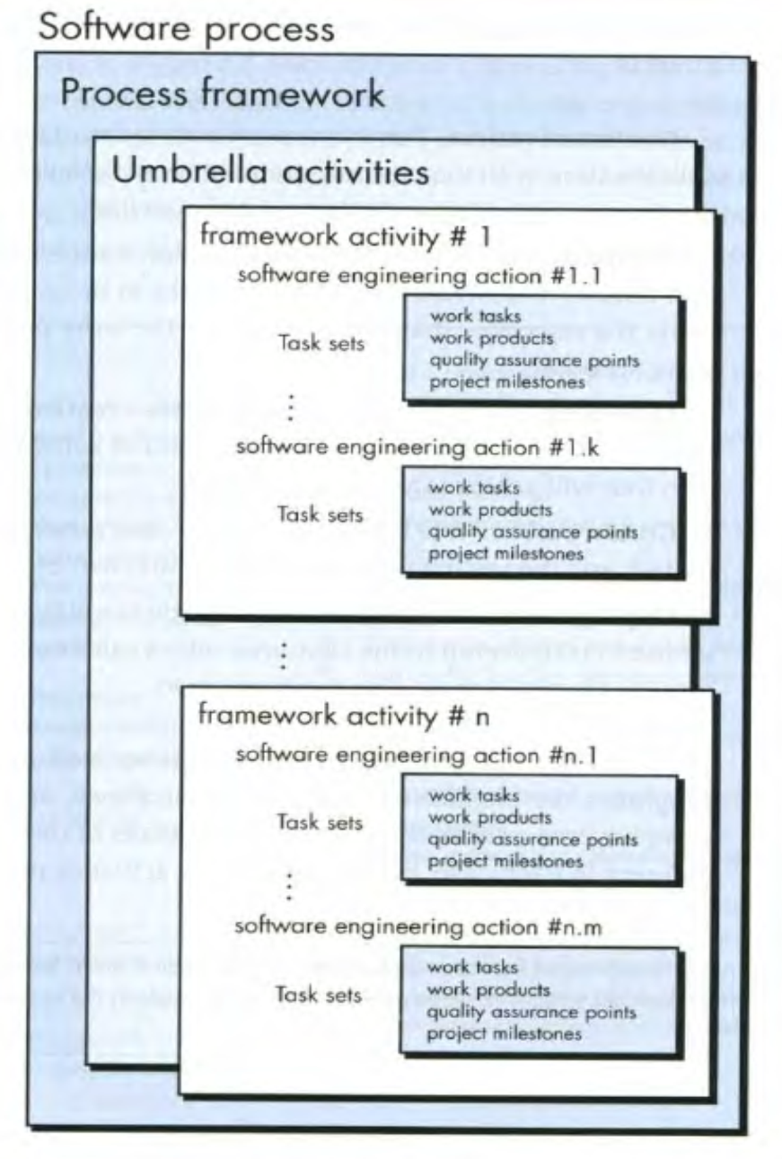Design;
  + Validation;
  + Evolution.
* A software process model is an abstract representation of a process. It presents a description of a process from some particular perspective.

**A Software Process Framework**

A process frameworkestablishes the foundation for a complete software engineering process by identifying a small number of *framework activities* that are applicable to all software projects, regardless of their size or complexity.

**Communication.** Before any technical work can commence, important to communicate and collaborate with the customer to understand stakeholders’ for the project and to gather requirements that help define software features and functions.

**Planning.** A software project is a complicated journey, and the planning activity creates a “map” that helps guide the team as it makes the journey. The map—called a software project plan  
**Modeling.** a bridge builder, an aeronautical engineer, a carpenter, or an architect, work with models every day. You create a “sketch” of the thing so that you’ll understand the big picture—what it will look like architecturally, how the constituent parts fit together, and many other characteristics.

**Construction.** What you design must be built. This activity combines code generation (either manual or automated) and the testing that is required to uncover errors in the code.

**Deployment. Software** is delivered to the customer who evaluates the delivered product and provides feedback based on the evaluation

**Umbrella Activities:**

The process framework encompasses a set of *umbrella activities* that are applicable across the entire software process. Typical umbrella activities include .

* **Software project tracking and control**—allows the software team to assess progress against the project plan and take any necessary action to maintain the schedule.
* **Risk management**—assesses risks that may affect the outcome of the project or the quality of the product.
* **Software quality assurance**—defines and conducts the activities required to ensure software quality.
* **Technical reviews**—assess software engineering work products in an effort to uncover and remove errors before they are propagated to the next activity.
* **Measurement**—defines and collects process, project, and product measures that assist the team in delivering software that meets stakeholders’ needs; can be used in conjunction with all other framework and umbrella activities.
* **Software configuration management**—manages the effects of change throughout the software process.
* **Reusability management**—defines criteria for work product reuse (including software components) and establishes mechanisms to achieve reusable components.
* **Work product preparation and production**—encompass the activities required to create work products such as models, documents, logs, forms, and lists.

**What is “Practice”?**

* Practice consists of the
  + concepts
  + principles
  + methods
  + tools
* that must be considered as software is planned and developed.
* It represents the details—the how-to’s—of the software process.

**The Essence of Practice:**

* George Polya, in a book written in 1945 (!), describes the essence of software engineering practice …
  + - *Understand the problem* (communication and analysis).
    - *Plan a solution* (modeling and software design).
    - *Carry out the plan* (code generation).
    - *Examine the result for accuracy* (testing and quality assurance).
* At its core, good practice is common-sense problem solving

**Core Software Engineering Principles**

1. Provide Value to Your Users
2. KIS (Keep It Simple)
3. Maintain the Vision
4. What You Produce, Others Will Consume
5. Be Open to the Future
6. Plan Ahead for Reuse
7. Think before You Do

**Software Engineering Practices**

* Consider the generic process framework
  + Communication
  + Planning
  + Modeling
    - Analysis Modeling
    - Design Modeling
  + Construction
    - Coding
    - Testing
  + Deployment
* Personal Software Process (PSP):
* Recommends five framework activities:
  + Planning
  + High-level design
  + High-level design review
  + Development
  + Postmortem
* Stresses the need for each software engineer to identify errors early and as important, to understand the types of errors

**Team Software Process (TSP)**

* Each project is “launched” using a “script” that defines the tasks to be accomplished
* Teams (of 2 to 20 engineers) are self-directed:
  + Plan and track work, set goals, own processes and plans
* Measurement is encouraged
* Measures are analyzed with the intent of improving the team process (through coaching, motivation, …)

**The Primary Goal of Any Software Process: *High Quality***



* **What?** A software process - a series of predictable steps that leads to a timely, high-quality product.
* **Who?** Managers, software engineers, and customers.
* **Why?** Provides stability, control, and organization to an otherwise chaotic activity.
* **Steps?** A handful of activities are common to all software processes, details vary.
* Work product? Programs, documents, and data.
* Correct process? Assessment, quality deliverable.

This aspect—called *process flow*—describes how the framework activities and the actions and tasks that occur within each framework activity are organized with respect to sequence and time and is illustrated in  
Figure 3.2.  
A *linear process flow* executes each of the five framework activities in sequence, beginning with communication and culminating with deployment (Figure 3.2a).

An *iterative process flow* repeats one or more of the activities before  
proceeding to the next (Figure 3.2b).

An *evolutionary process flow* executes the  
activities in a “circular” manner. Each circuit through the five activities leads  
to a more complete version of the software (Figure 3.2c).

A *parallel process flow*(Figure 3.2d) executes one or more activities in parallel with other activities (e.g.,  
modeling for one aspect of the software might be executed in parallel with construction of another aspect of the software).

**DEFINING A FRAMEWORK ACTIVITY:**

we have described five framework activities and provided a basic definition of each in Chapter 2, a software team would need significantly more information before it could properly execute any one of these activities as part of the  
software process.

**Process flow:**

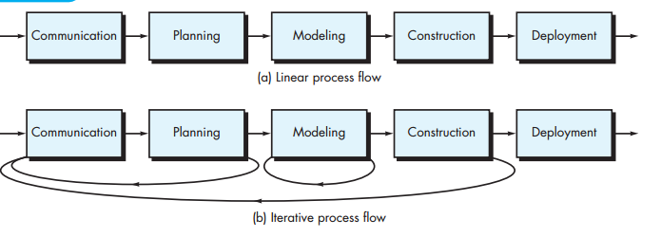

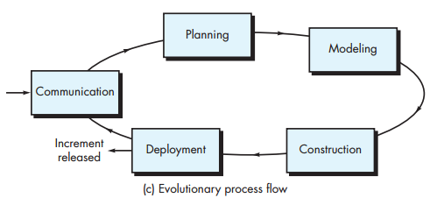

**IDENTIFYING A TASK SET:**

each software engineering action (e.g., *elicitation,* an action associated with the **communication** activity) can be represented by a number of different *task sets*—

Task of Communication:

1. Make a list of stakeholders for the project.  
2. Invite all stakeholders to an informal meeting.  
3. Ask each stakeholder to make a list of features and functions required.  
4. Discuss requirements and build a final list.  
5. Prioritize requirements.  
6. Note areas of uncertainty

**PROCESS PATTERNS:**

A *process pattern*1 describes a process-related problem that is encountered during software engineering work,

**Pattern Name.** The pattern is given a meaningful name describing it within the context of the software process (e.g., **TechnicalReviews**).   
**Forces.** The environment in which the pattern is encountered and the issues that make the problem visible and may affect its solution.  
**Type.** The pattern type is specified. Ambler [Amb98] suggests three types:  
**1. Stage pattern**—defines a problem associated with a framework activity for the process.

**2. Task pattern**—defines a problem associated with a software engineering action or work task and relevant to successful software engineering practice (e.g., **RequirementsGathering** is a task pattern).  
**3. Phase pattern**—define the sequence of framework activities that occurs within the process, even when the overall flow of activities is iterative in nature. An example of a phase pattern might be **SpiralModel** or **Prototyping**.

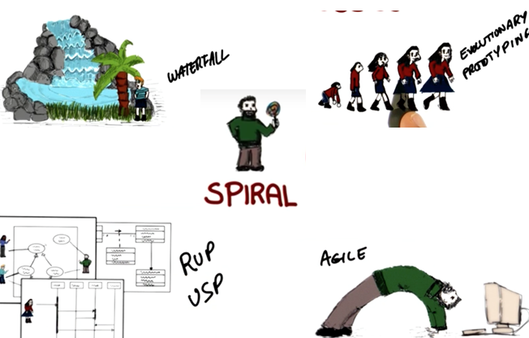

* **Phase:**
* Definition Phase
  + Focus on ‘what’ the software is
* Development Phase
  + Focus on ‘how’ the software works
* Maintenance Phase
  + Focus on ‘change’ to the software

**Definition Phase**

* Identify information to be processed
* Identify system behavior - functions and performance
* Determine constraints, interfaces, validation criteria
* Major tasks:
  + System engineering
  + Software project planning
  + Requirements analysis

**Development Phase**

* Define data structures, function implementation, procedural details, interfaces
* Translate design to programming language
* How testing is performed
* Major tasks:
  + Software design
  + Code generation
  + Software testing

**Maintenance Phase**

* Reapplies definition and development phases to existing software
* Types of changes:
  + Correction
  + Adaptation
  + Enhancement
  + Prevention

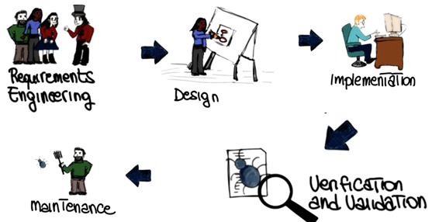**Traditional Software Phases:**

* the software development process contains fundamental activities, or phases.
* Since we will discuss several processes, I'm going to remind you what these phases are.
* We start with requirements engineering, followed by design, implementation, verification and validation, and finally maintenance.
* Note that we will revisit each of these phases and devote an entire lesson or more to each phase. So what I want to do next is simply to give you a quick overview of what these phases are.
* Note also that for now I will follow a very traditional take on these topics. Later on in the class we will see how things can change and did change over the years.

**Requirements Engineering:**

**which is the field within software engineering that deals with establishing the needs of stakeholders that are to be solved by the software.**

* This is the field within software engineering that deals with establishing the needs of stakeholders that are to be solved by the software.
* So why is this phase so important?

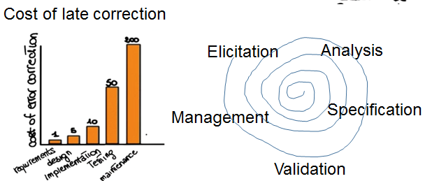

* In general, the cost of correcting an error depends on the number of subsequent decisions that are based on it. Therefore, errors made in understanding requirements have the potential for greatest cost because many other design decisions depend on them and many other follow up decisions depend on them.
* In fact, if we look at this diagram, which is again a qualitative diagram, where we have the cost of error correction over the phase in which the error is discovered.
* We can see that if we discover an error in requirements it's going to cost us one. If we find it in in design it's going to cost us five and so on and so forth. And the cost grows dramatically as we go from the requirements phase to the maintenance phase.
* Why? Because of course if we discover a problem here we're left to undo a lot of the decision that we had made before to correct the error. Whereas if we find an error here we can correct it right away and we don't affect the subsequent phases. So how can we collect the right requirements. Traditional requirements in engineering does so through a set of steps.
* The first step is elicitation which is the collection of requirements from stake holders and other sources and can be done in a variety of ways, we will discuss some of them.
* The second is requirement analysis which involved the study and deeper understanding of the collective requirements.
* The third step is this specification of requirements, in which the collective requirements are suitably represented, organized and save so that they can be shared. Also in his case, there are many ways to do this, and we will see some of this ways when we talk about the requirements engineering in the dedicated lesson.
* Once the requirements have been specified, they can be validated to make sure that they're complete, consistent, no redundant and so on. So that they've satisfied a set of importance properties, for requirements.
* Finally, the fifth step is requirements management which accounts for changes to requirements during the lifetime of the project.
* And here I talked about steps, kind of giving the impression that we're just going from the first step to the fifth one and that this is sort of a linear process.
* In reality, as we will see, this is more of an iterative process in which will go and cover the different phases in an iterative fashion.
* We will discuss extensively requirements engineering in our second mini-course.

**Design:**

**Design Activities**

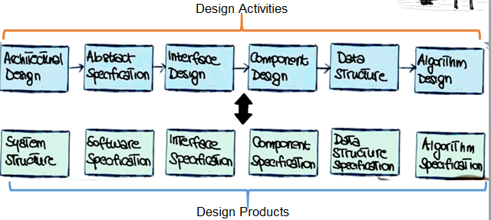

Now let's discuss the next phase of software development, which is software design.

Software design is the phase where software requirements are analyzed in order to produce a description of the internal structure and organization of the system.

And this description will serve as the basis for the construction of the actual system.

Traditionally, the software design phase consists of a series of design activities.

Which normally consists of the architectural design phase, the abstract specification, interface design, component design, data structure and algorithm design.

And notice that this is just a possible list of activities. But you can also characterize design activities in many different ways. And if you're looking at different books, and different sources, you might find different activities described. But the core idea, the important point is that we go from sort of a high-level view of the system, which is the architectural design, to a low-level view, which is the algorithm design.

And these activities result in a set of design products, which describe various characteristics of the system.

For example, they describe the architecture of the system, so how the system is decomposed and organized into components, the interfaces between these components.

They also describe these components into a level of details that is suitable for allowing their construction.

We will discuss the details of software design and talk extensively about these different actives and these different products in subsequent class.

**Implementation:**

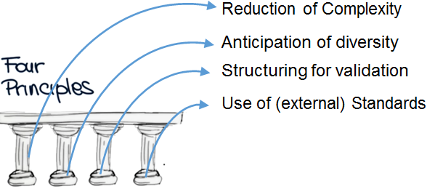

* After we have designed our system we can implement it. In the implementation phase what we do is basically taking care of realizing the design of the system that we just created and create an actual software system. There are four fundamental principles, four pillars that can affect the way in which software is constructed.
* The first one is the reduction of complexity. This aims to build software that is easier to understand and use.
* The second pillar is the anticipation of diversity. Which takes into account that software construction might change in various way overtime. That is that software evolves. In many cases, it evolves in unexpected ways. And therefore, we have to be able to anticipate some of these changes.
* The third pillar is the structuring for validation. Also called design for testability. And what this means is that we want to build software so that it is easily testable during the subsequent validation and verification activities.
* Finally, and this is especially true within specific organizations and or domains. It is important that the software conforms to a set of internal or external standards. And some examples of this might be, for example, for internal standards, coding standards within an organization, or naming standards within an organization.
* As for external standards, if for example you are developing some medical software. There are some regulations and some standards that you have to adhere to in order for your software to be valid in that domain.

**Verification & Validation:**

* Validation: did we build the right system?
* Verification: did we build the system right?

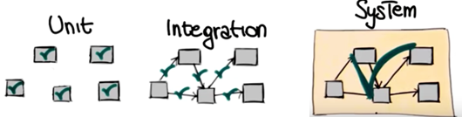

* **After we have built our system, verification and validation is that phase of software development that aims to check that the software system meets its specification and fulfills its intended purpose. More precisely, we can look at verification and validation independently.**
* **And validation is the activity that answers the question did we build the right system. Did we build the system that the customer wants? That will make the customer happy.**
* **Whereas verification answers a different question which is did we build the system right. So given a description of the system that is the one that we derived from the customer through the collection of requirements and then design and so on, did we build a system that actually implements the specification that we defined?**
* **And when we look at verification there's many, many ways of doing verification. The only thing I want to mention here is the fact that verification can be performed at different levels.**
* **In particular, it can be performed at the unit level in which we test that the individual units work as a expected.**
* **Can be performed in the integration level in which what we test is the interaction between the different units. So we want to make sure that the different modules talk to each other in the right way.**
* **And finally, there is system testing in which we test the system as a whole and we want to make sure that all the system, all the different pieces of the system work together in the right way.**
* **And this is also the level at which then we will apply validation and some other testing techniques like stress testing or robustness testing and so on. And as I said I'm not going to say anything more on this topic because we will cover verification, and validation, and testing in particular in great details in later section**

**Maintenance**

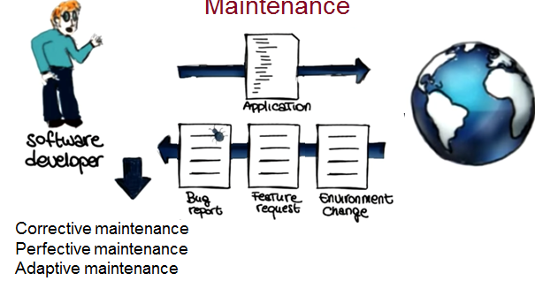

* As we discussed before software development efforts normally result in the delivery of a software product that satisfies the user requirements.
* So normally our software development organization will release this application to its final users, however, once the software is in operation many things can happen.
* So, for example, the environment might change. There might be new libraries. There might be new systems in which our software has to operate.
* Or they may be future requests, so the users may find out that, guess what, they want to do something different with the problem that we gave them.
* Or, again, and this is one of the most common occurrences, users might find problems with the software and may file bug reports and send the bug reports back to the software developer.
* These are the reasons why software maintenance is a necessary phase in software development.
* Software maintenance is the activity that sustains the software product as it evolves throughout its life cycle, specifically in response to bug reports, feature requests and environment changes. Development organizations perform three kinds of maintenance activities:
* corrective maintenance to eliminate problems with the code, perfective maintenance to accommodate feature request, and in some cases just to improve the software, for example, to make it more efficient, and finally, adaptive maintenance, to take care of the environment changes.
* And after this activities have been performed, the software developer will produce a new version of the application, will release it and the cycle will continue through out the lifetime of the software.
* That's why maintenance is a fundamental activity and a very expensive one. And one of the reasons why maintenance is expensive, that I want to mention now, is regression testing.
* During maintenance every time you modify your application you have to regression test the application, where regression testing is the activity of retesting software after it has been modified to make sure that the changes you perform to the software work as expected, and that your changes did not introduce any un foreseen effect.
* I'm pretty sure that you're familiar with the case of a new version of the software being released and just a couple of days later another version being released to fix some problems that occur with the new version. These problems is what we call regression errors and they're what regression testing targets and tries to eliminate before the new version of the software is released into the world.

**What are the traditional software phases?**

* **Requirements engineering, design, abstraction, implementation, verification & validation?**
* **Design, optimization, implementation, verification & validation, maintenance**
* **Requirements engineering, design, implementation, verification & validation, maintenance**
* **Okay. Now before we jump into the next topic, I just want to take a very quick and simple quiz just to make sure that you guys paid attention to what I just discussed.**
* **So I want to ask you what are the traditional software phases.**
* **Requirements engineering, design, abstraction, implementation, verification and validation.**
* **Or maybe design, optimization, implementation verification and validation and maintenance.**
* **Or requirements engineering, design, implementation, verification and validation, and maintenance.**

**Software Process/Lifecycle Model**

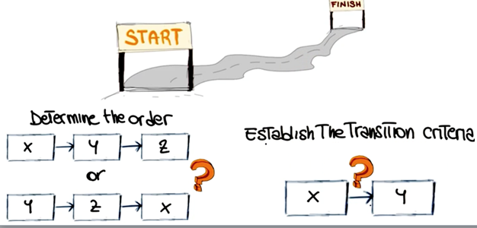

**At this point, you know the possible activities, the possible phases performed during the software development process.**

**But there this something that we still haven't discussed, which is very important. And that is how should we put these activities together to develop software? And this all comes down to the concept of software process model. Also called software lifecycle model.**

**And what this is, is a prescriptive model of what should happen from the very beginning to the very end. Of a software development process.**

**The main function of the life cycle model is to determine the order of the different activities so that we know which activities should come first and which ones should follow.**

**Another important function of the life cycle model is to determine the transition criteria between activities. So, when we can go from one phase to the subsequent one.**

**In other words, what the model should describe is what should we do next and how long should we continue to do it for each activity in the model. Now lets see a few traditional software process models. I will discuss them here at the high level**



**CHAPTER 4 Process Models**

Generic software Process Model

* Models:
  + Waterfall model or classic life cycle
  + The evolutionary models
    - Prototyping
    - The Spiral model
    - The Concurrent development model
  + Incremental process model
    - The incremental model
    - RAD (Rapid Application Development) model
  + Specialized process models
    - Component based development
    - The formal methods model
    - Aspect Oriented Software Development (AOSD)
  + The Unified process model

**Waterfall Model**

**The *waterfall model,* sometimes called the *classic life cycle* to software development that begins with customer specification of requirements and progresses through planning, modeling, construction, and deployment, culminating in ongoing support of the completed software**

* Waterfall model is the simplest model of software development paradigm.
* All the phases of SDLC when the first phase is finished then only the second phase will start and so on.
* This model assumes that everything is carried out and taken place perfectly as planned in the previous stage and there is no need to think about the past issues  
  that may arise in the next phase.
* This model does not work smoothly if there are some issues left at the previous step.
* The sequential nature of model does not allow us to go back and undo or redo our actions.
* This model is best suited when developers already have designed and developed  
  similar software in the past and are aware of all its domains.

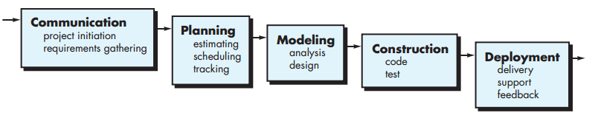

**V – model:**

A variation in the representation of the waterfall model is called the *V-model*. Represented in Figure 4.2, the V-model [Buc99] depicts the relationship of quality assurance actions to the actions associated with communication, modeling, and early construction activities

* The major drawback of waterfall model is we move to the next stage only when the previous one is finished and there was no chance to go back if something is found wrong in later stages.
* V-Model provides means of testing of software at each stage in reverse manner.
* At every stage, test plans and test cases are created to verify and validate the product according to the requirement of that stage.
* For example, in requirement gathering stage the test team prepares all the test cases in correspondence to the requirements.
* Later, when the product is developed and is ready for testing, test cases of this stage verify the software against its validity towards requirements at this stage.  
  This makes both verification and validation go in parallel.
* **This model is also known as verification and validation model**.

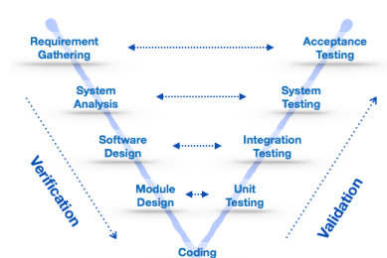

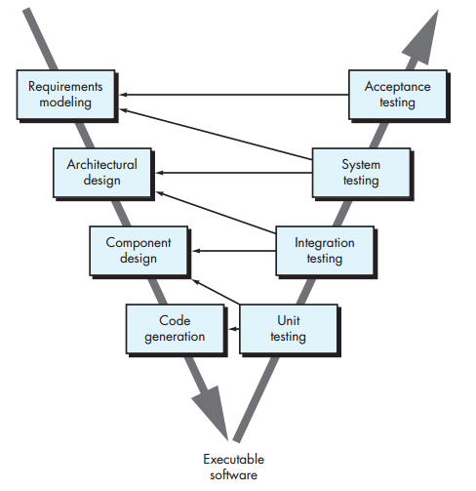

**Figure 4.2 V-model**

**Among the problems that are sometimes encountered when the waterfall model is applied are**

1. Real projects rarely follow the sequential flow that the model proposes. Although the linear model can accommodate iteration, it does so indirectly. As a result, changes can cause confusion as the project team proceeds
2. It is often difficult for the customer to state all requirements explicitly. The waterfall model requires this and has difficulty accommodating the natural uncertainty that exists at the beginning of many projects
3. The customer must have patience. A working version of the program(s) will not be available until late in the project time span. A major blunder, if undetected until the working program is reviewed, can be disastrous.

**Incremental Process Models**

Sometimes clients Provided a limited set of functionality and expand functionality in later software release. The incremental model combines the elements’ linear and parallel process flows

For example, word-processing software developed using the incremental paradigm might deliver

* basic file management, editing, and document production functions in the first increment;
* more sophisticated editing and document production capabilities in the second increment;
* spelling and grammar checking in the third increment; and
* advanced page layout capability in the fourth increment.
* It should be noted that the process flow for any increment can incorporate the prototyping paradigm.

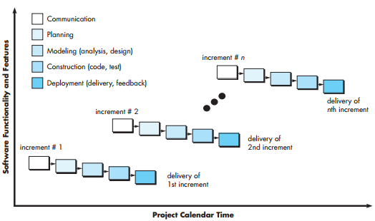

* When an incremental model is used, the first increment is often a *core product.*
* That is, basic requirements are addressed but many supplementary features (some known, others unknown) remain undelivered.
* The core product is used by the customer (or undergoes detailed evaluation).
* As a result of use and/ or evaluation, a plan is developed for the next increment.
* The plan addresses the modification of the core product to better meet the needs of the customer and the delivery of additional features and functionality.
* This process is repeated following the delivery of each increment, until the complete product is produced.

**Evolutionary Process Models:**

Business and product requirements often change as development proceeds, making a straight line path to an end product unrealistic; a set of core product or system requirements is well understood, but the details of product or system extensions have yet to be defined. In these and similar situations, you need a process model that has been explicitly designed to accommodate a product that grows and changes.

In the paragraphs that follow, we present two common evolutionary process models:

**Prototyping.** Often, a customer defines a set of general objectives for software, but does not identify detailed requirements for functions and features. In other cases, the developer may be unsure of the efficiency of an algorithm, In these situations, a *prototyping paradigm* may offer the best approach.

The prototyping paradigm (Figure 4.4) begins with communication to identify whatever requirements are known, and outline areas where further definition is mandatory. A prototyping iteration is planned quickly, and modeling (in the form of a “quick design”) occurs.

The quick design leads to the construction of a prototype. The prototype is deployed and evaluated  
by stakeholders, who provide feedback that is used to further refine requirements. Iteration occurs as the prototype is tuned to satisfy the needs of various stakeholders, while at the same time enabling you to better understand what needs to be done. If a working prototype is to be built, you can make use of existing program fragments or apply tools that enable working programs to be generated quickly

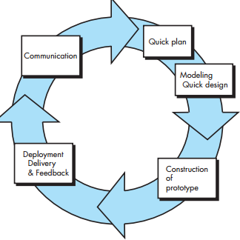

**The Spiral Model** the *spiral model* is an evolutionary software process model that couples the iterative nature of prototyping with the controlled and systematic aspects of the waterfall model. Using the spiral model, software is developed in a series of evolutionary releases. During early iterations, the release might be a model or prototype. During later iterations, increasingly more complete versions of the engineered system are produced. A spiral model is divided into a set of framework activities defined by the software engineering team.

* 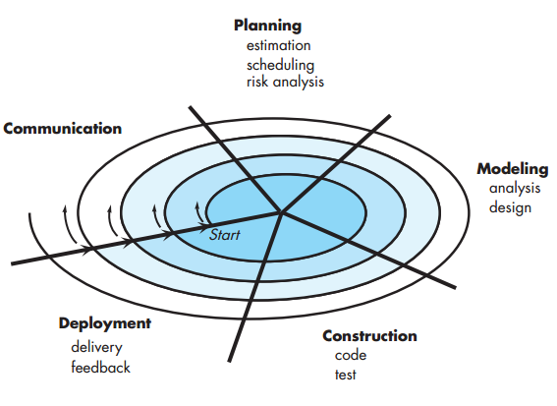Simplified form
  + Waterfall model plus risk analysis
* Precede each phase by
  + Alternatives
  + Risk analysis
* Follow each phase by
  + Evaluation
  + Planning of next phase

v

* And one of the main characteristics of that paper is that it was describing the spiral model using a diagram, which is the one that I'm showing you here, and this diagram has become very very popular, and you probably saw it either in this form or one of the many variations of the diagram.
* So I'm not going to discuss all of the details of the spiral model, but I just want to give you an idea of its main characteristics.
* The spiral model is an incremental risk-oriented lifecycle model that has four main phases listed here:
* determine objectives, identify and resolve risks, development and tests, and plan the next iteration.
* A software project will go through these four phases in an iterative way. In the first phase, the requirements will be gathered. In the second phase, the risks and the alternate solutions will be identified, and a prototype will be produced. Software and tests for the software are produced in the development and test phase, which is the third step of the process. Finally, in the fourth phase, the output of the project, so far, is evaluated, and the next iteration is planned. So basically, what the spiral process prescribes is a way of developing software by going through these phases in an iterative way, in which we learn more and more of the software, we identify more and more, and account for, more and more risks and we go more and more towards our final solution, our final release. There are several advantages of using a spiral model. The first one is that the extensive risk analysis does reduce the chances of the project to fail. So there is a risk reduction advantage. The second advantage is that functionality can be added at a later phase because of the iterative nature of the process. And finally, software is produced early in the software lifecycle. So, at any iteration, we have something to show for our development. We don't wait until the end before producing something. And then of course there's also the advantage that we can get early feedback from the customer about what we produced. The main disadvantages on the other hand of the spiral model, are that the risk analysis requires a highly specific expertise. And unfortunately, the whole success of the process is highly dependent on risk analysis. So risk analysis has to be done right. And finally the spiral model is way more complex than other models, like for example, the water fall model. And therefore it can be costly to implement.

**Concurrent Models:**

* The *concurrent development model,* sometimes called *concurrent engineering,* allows a software team to represent iterative and concurrent elements of any of the process models
* An activity—**modeling**—may be in any one of the states7 noted at any given time. Similarly, other activities, actions, or tasks (e.g., **communication** or **construction**) can be represented in an analogous manner. All software engineering activities exist concurrently but reside in different states
* For example, early in a project the communication activity (not shown in the figure) has completed its first iteration and exists in the **awaiting changes** state. The modeling activity (which existed in the **none** state while initial communication was completed) now makes a transition into the **under development** state. If, however, the customer indicates that changes in requirements must be made, the modeling activity moves from the **under development** state into the **awaitingchanges** state

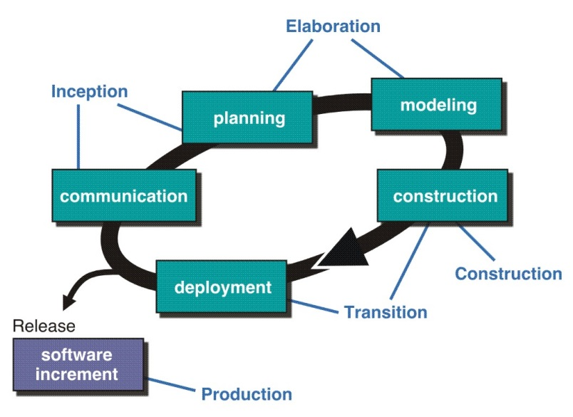

Unified Process Model

A software process that is:

* + use-case driven
  + architecture-centric
  + iterative and incremental

Closely aligned with the

Unified Modeling Language (UML)

**Rational Unified Process(RUP**

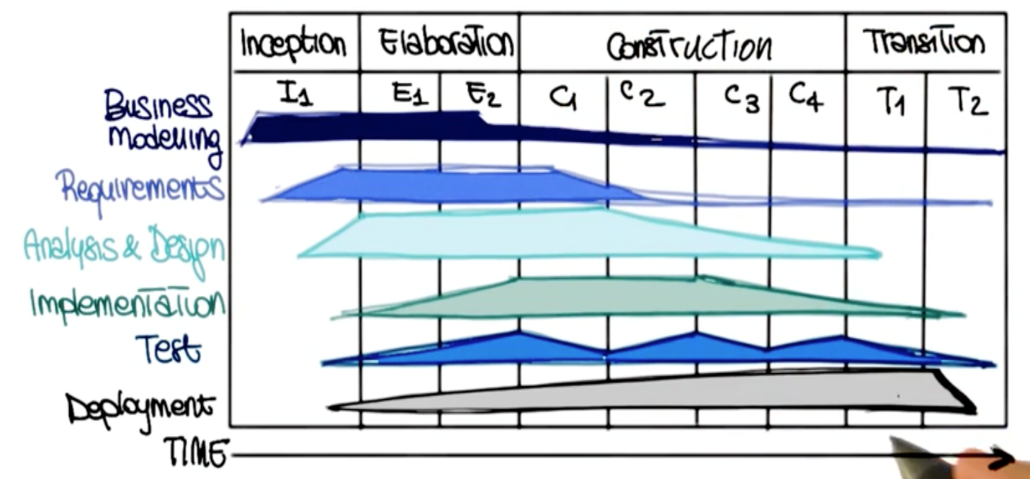

There are two more software process models that I want to cover, so bear with me. The first one is the Rational Unified software Processor IUP, which is s a very popular one based on UML.

RUP works in an iterative way, which means it that it performs different iterations. And at each iteration, it performs four phases. So what I'm showing you here, is a high level view of the process.

And I don't want you to focus on all the different details, because we will discuss these details later on, in a lesson that is actually dedicated to RUP. What I want to give you now, is just the gist of how this works. So, in each one of these four phases, which I'm going to describe in a second.

We perform standard software engineering activities, the ones that we just discussed. And we do them to different extent, based on the phase in which we are. In particular, in the inception phase the work is mostly to sculpt the system.

So basically figuring out what is the scope of the work, what is the scope of the project, what is the domain. So that we can be able to perform initial cost and budget estimates. The operational phase is the phase in which we focus on the domain analysis and define the basic architecture for the system. So this is a phase in which analysis and design are particularly paramount. Then there is a construction phase, which is where the bulk of the development actually occurs. And as you can see here, is where most of the implementation happens. And finally, the transition phase is the phase in which the system goes from development into production, so that it becomes available to users. And of course, this is the phase in which the other activities in software development become less relevant and deployment becomes the main one.



**CHAPTER 5 Agile Development (Scrum, XP, Lean, Kanban)**

**What is “Agility”?**

* Effective (rapid and adaptive) response to change
* Effective communication among all stakeholders
* Drawing the customer onto the team
* Organizing a team so that it is in control of the work performed
* *Yielding …*
* Rapid, incremental delivery of software

**What is it? Agile software engineering combines a philosophy and a set of development guidelines. The philosophy encourages customer satisfaction and early incremental delivery of software; small, highly motivated project teams; informal methods; minimal software engineering work products; and overall development simplicity.** The development guidelines stress delivery over analysis and design (although these activities are not discouraged), and active and continuous communication  
between developers and customers.

**Who does it?** Software engineers and other project stakeholders (managers, customers, end users) work together on an agile team—a team that is self-organizing and in control of its own destiny. An agile team fosters communication and collaboration among all who serve on it.

**Why is it important?** The modern business environment that spawns computer-based systems and software roducts is fast-paced and ever-changing. Agile software engineering represents a reasonable alternative to conventional software engineering for certain classes of software and certain types of software projects. It has been demonstrated to deliver successful systems quickly.  
**What are the steps?** Agile development might best be termed “software engineering lite.” The basic framework activities—communication, planning, modeling, construction, and deployment—remain. But they morph into a minimal task set that pushes the project team toward construction and delivery (some would argue that this is done at the expense of problem analysis and solution design).  
**What is the work product?** Both the customer and the software engineer have the same view—the only really important work product is an operational “software increment” that is delivered to the customer on the appropriate commitment date.

**How do I ensure that I’ve done it right?** If the agile team agrees that the process works, and the team produces deliverable software increments that satisfy the customer, you’ve done it right.

**WHAT IS AN AGILE PROCESS?**

Any agile software process is characterized in a manner that addresses a number of key assumptions about the majority of software projects:

**1.** It is difficult to predict in advance which software requirements will persist and which will change. It is equally difficult to predict how customer priorities will change as the project proceeds.

2. For many types of software, design and construction are interleaved. That is, both activities should be performed in tandem so that design models are proven as they are created. It is difficult to predict how much design is necessary before construction is used to prove the design.  
**3.** Analysis, design, construction, and testing are not as predictable (from a planning point of view) as we might like

Given these three assumptions, an important question arises: How do we create a process that can manage *unpredictability*? The answer, as we have already noted, lies in process adaptability (to rapidly changing project and technical conditions). An agile process, therefore, must be *adaptable.*

**Agility and the cost of change:**

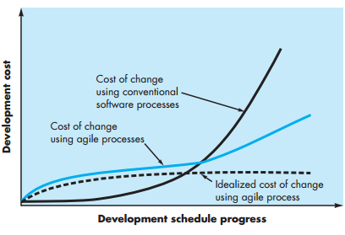

**Figure 5.1: Change costs as a function of time in development**

The conventional wisdom in software development (supported by decades of experience) is that the cost of change increases nonlinearly as a project progresses (Figure 5.1, solid black curve). It is relatively easy to accommodate a change when a software team is gathering requirements (early in a project). A usage scenario might have to be modified, a list of functions may be extended, or a written

Costs escalate quickly, and the time and cost required to ensure that the change is made without unintended side effects is nontrivial. **Proponents of agility argue that a well-designed agile process “flattens” the cost of change curve (Figure 5.1, shaded, solid curve), allowing  
a software team to accommodate changes late in a software project without dramatic cost and time impact.**

**An Agile Process:**

* Is driven by customer descriptions of what is required (scenarios)
* Recognizes that plans are short-lived
* Develops software iteratively with a heavy emphasis on construction activities
* Delivers multiple ‘software increments’
* Adapts as changes occur

**Principles of Agility:**

1. Our highest priority is to **satisfy the customer** through early and continuous delivery of valuable software.
2. Welcome **changing requirements**, even late in development. Agile processes harness change for the customer’s competitive advantage.
3. **Deliver working software frequently**, from a couple of weeks to a couple of months, with a preference to the shorter time scale.
4. **Business people and developers must work together** daily throughout the project.
5. Build projects around **motivated individuals**. Give them the environment and support they need, and trust them to get the job done.
6. The most efficient and effective method of **conveying information** to and within a development team is **face-to-face conversation**.
7. Working software is the **primary measure of progress**.
8. Agile processes **promote sustainable development**. The sponsors, developers, and users should be able to maintain a constant pace indefinitely.
9. **Continuous attention to technical** excellence and good design enhances agility.
10. **Simplicity -** the art of maximizing the amount of work not done - is essential.
11. The **best architectures, requirements, and designs** emerge from self-organizing teams.
12. At **regular intervals, the team reflects** on how to become more effective, then tunes and adjusts its behavior accordingly.

**Extreme Programming (XP):**

* An object-oriented approach as its preferred development paradigm and encompasses a set of rules and practices that occur within the context of four framework activities: planning, design, coding and testing.
* XP Planning
  + Begins with the creation of user stories
  + Agile team assesses each story and assigns a cost
  + Stories are grouped to for a deliverable increment
  + A commitment is made on delivery date
  + After the first increment project velocity is used to help define subsequent delivery dates for other increments
* XP Design
  + Follows the KIS principle
  + Encourage the use of CRC cards (see Chapter 8)
  + For difficult design problems, suggests the creation of spike solutions — a design prototype
  + Encourages refactoring — an iterative refinement of the internal program design
* XP Coding
  + Recommends the construction of a unit test for a store *before* coding commences
  + Encourages pair programming
* XP Testing
  + All unit tests are executed daily
  + 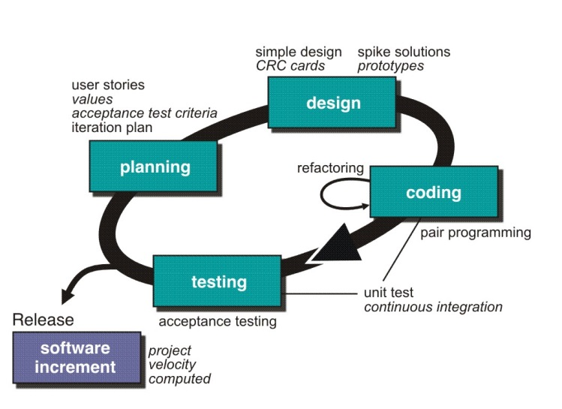Acceptance tests are defined by the customer and executed to assess customer visible functionality

**Industrial XP:**

“IXP is an organic evolution of XP. It is imbued with XP’s minimalist, customer-centric, test-driven spirit

**Readiness assessment.** The IXP team ascertains whether all members of the project community (e.g., stakeholders, developers, management) are on board, have the proper environment established, and understand the skill levels involved.  
**Project community.** The IXP team determines whether the right people, with the right skills and training have been staged for the project. The “community” encompasses technologists and other stakeholders.  
**Project chartering.** The IXP team assesses the project itself to determine whether an appropriate business justification for the project exists and whether the project will further the overall goals and objectives of the organization.  
**Test-driven management.** An IXP team establishes a series of measurable “destinations” [Ker05] that assess progress to date and then defines mechanisms for determining whether or not these destinations have been reached.  
**Retrospectives.** An IXP team conducts a specialized technical review after a software increment is delivered. Called a *retrospective,* the review examines “issues, events, and lessons-learned” [Ker05] across a software increment and/or the entire software release.  
**Continuous learning.** The IXP team is encouraged (and possibly, incented) to learn new methods and techniques that can lead to a higher-quality product.

**Other Agile Processes:**

* Scrum
* Dynamic Systems Development Method (DSDM)
* Adaptive Software Development (ASD)
* Feature Driven Development
* Agile Modeling (AM)

**Agile Modeling**

There are many situations in which software engineers must build large, business-critical systems. The scope and complexity of such systems must be modeled so that

* **Model with a purpose.** A developer who uses AM should have a specific goal in mind before creating the model. Once the goal for the model is identified, the type of notation to be used and level of detail required will be more obvious.
* **Use multiple models.** There are many different models and notations that can be used to describe software. Only a small subset is essential for most projects..
* **Travel light.** As software engineering work proceeds, keep only those models that will provide **long-term value and jettison the rest**. Every work product that is kept must be maintained as changes occur
* **Content is more important than representation.** Modeling should impart information to its intended audience. A syntactically perfect model that imparts little useful content is not as valuable as a model with flawed notation that nevertheless provides valuable content for its audience.

**Agile Unified Process**

1. ***Modeling****.* UML representations of the business and problem domains are created. However, to stay agile, these models should be “just barely good enough” [Amb06] to allow the team to proceed.
2. ***Implementation.***Models are translated into source code.
3. ***Testing.***Like XP, the team designs and executes a series of tests to uncover errors and ensure that the source code meets its requirements.
4. ***Deployment.***Like the generic process activity discussed in Chapters 3,deployment in this context focuses on the delivery of a software increment and the acquisition of feedback from end users.
5. ***Configuration and project management.***In the context of AUP, configuration management (Chapter 29) addresses change management, risk management, and the control of any persistent work products12 that are produced by the team. Project management tracks and controls the progress of the team and coordinates team activities
6. ***Environment management****.* Environmental management coordinates a process infrastructure that includes standards, tools, and other support technology available to the team.

**A tool set for the agile process**:

Some proponents of the agile philosophy argue that automated software tools (e.g., design tools) should be viewed as a minor supplement to the team’s activities, and not at all pivotal to the success of the team. However, Alistair Cockburn [Coc04] suggests that tools can have a benefit and that “agile teams stress using tools that permit the rapid flow of understanding. Some of those tools are social, starting even at the hiring stage. Some tools are technological, helping distributed teams simulate being physically present. Many tools are physical, allowing people to manipulate them in workshops.

**Agile software engineering**

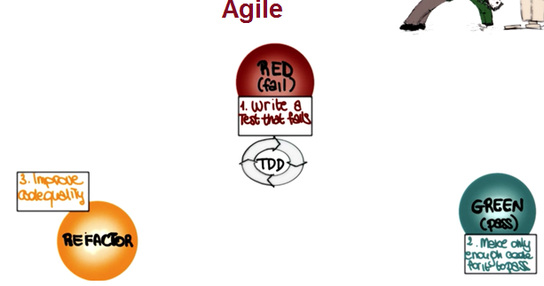Agile software engineering combines a philosophy and a set of development guidelines. The philosophy encourages customer satisfaction and early incremental delivery of software; small, highly motivated project teams; informal methods; minimal software engineering work products; and overall development simplicity. The development guidelines stress delivery over analysis and design (although these activities are not discouraged), and active and continuous communication between developers and customers.

The next type of software process models that I want to discuss are Agile Software Development Processes. And this is a group of software development methods that are based on highly iterative and incremental development. And in particular, I'm going to discuss Test Driven Development or TDD. The space on the iteration of three main phases. In the first one that we mark as red, we write test cases that encode our requirements, and for which we haven't written code yet. And therefore, they will fail, obviously. So we're in this sort of red or fail phase. From this phase, we move to this phase, in which after we write the just enough code to make the test cases pass. We have a set of test cases that are all passing. And therefore, we can consider this as the green phase. We had enough code to make the test cases pass because the test cases encode our requirements. We have just written enough code to satisfy our requirements. When we do this over time though, what happens is that the structure of the code deteriorates, because we keep adding pieces. So that's why we have the first step, which is refactoring. In this step, we modify the code, and we will talk about refactoring extensively. We'll devote one lesson to it. We modify the code to make it more readable, more maintainable. In general, we modify to improve the design of the code. And after this phase, we will go back to writing more test cases for new requirements, write code that makes these test cases pass, and so on. So we'll continue to iterate among these phases. And also, in this case, we will talk about Agile Software Processes. And in particular, about extreme programming, or XP, and Scrum in more details, in minor course number four.

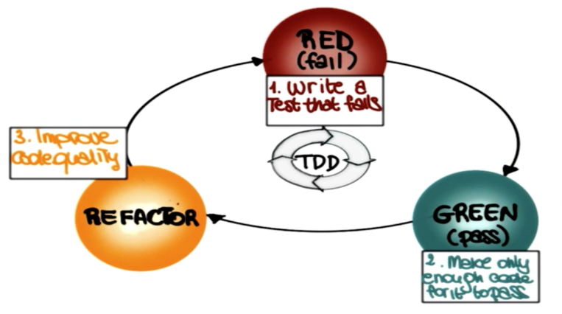

**Choosing a Software Process Model**

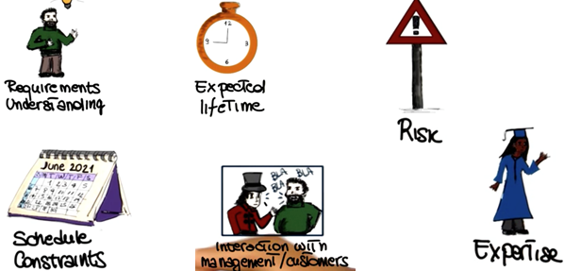

We just saw several software process models, and thereare many, many more. And because these process models definethe master plan for our project, the specific processmodel that we choose has as much influence over aproject's success as any other major planning decision thatwe make. Therefore, it is very important that we pickthe appropriate model for our development process. Picking an appropriatemodel can ensure the success of a project. On thecontrary, if we choose the wrong model, that can be aconstant source of problems and ultimately, it can make the projectfail. So how can we choose the right model for aproject? To be able to do so, we have to take intoconsideration many factors. In particular, we need to be aware ofwhat level of understanding we have of the requirements. Do we understandall the requirements? Are we going to be able to collect allthe requirements in advance, or collecting requirements is going to be hard andtherefore, we might want to follow a process that is more flexiblewith that respect. Another important point is the expected lifetime of theproject. Is this a quick project that we are putting together fora specific purpose or something that's going to last for for a numberof years and that we're going to maintain over all those years?That's going to make a difference in the way we decide to developthat project. Also, what is the level of risk involved? Do weknow the domain very well? Do we know exactly the technologies involved?Well, if so, we might go with a more traditional process. Otherwise,we might want to be more agile, more flexible. It is alsovery important to know the schedule constraints. How much time, how manyresources do we have for this project? What is the expected interactionwith the management and the customer? In particular for this ladder, thereare many processes that rely on the fact that there can bea continuous interaction with the customer. If that interaction is not there,there's no way we are going to be able to use these processes.Conversely, there are processes that don't require the presence of the customerat all, except for the initial phase and maybe some checking points andso if the customer is very inaccessible, we might want to followone of those processes, instead of one of the more demanding ones interms of customer's time. Finally, it is important to take into accountthe level of the expertise of the people involved. Do we have peoplethat know the technologies that we're using? Do we know people thatknow a specific kind of process?Some processes require some specific expertise andwe're not going to be able to follow that process if we don'thave the right expertise. So we need to take into account all ofthese aspects, and sometimes more, in order to be able to makethe right decision and pick the right software process model for our project.

Question: which of the following models is most suitable to develop a software Engineering System.

* Pure waterfall model
* TDD
* Evolutionary Prototyping

Agile software engineering combines a philosophy and a set of development guidelines. The philosophy encourages customer satisfaction and early incremental delivery of software; small, highly motivated project teams; informal methods; minimal software engineering work products; and overall development simplicity. The development guidelines stress delivery over analysis and design (although these activities are not discouraged), and active and continuous communication between developers and customers.



**CHAPTER 7 Principles That Guide Practice**

**What is practice? Software engineering practice is a broad array of principles, concepts, methods, and tools that you must consider as software is planned and developed.** Principles that guide practice establish a foundation from which software engineering is conducted.

**Who does it?** Practitioners (software engineers) and their managers conduct a variety of software engineering tasks.  
**Why is it important?** The software process provides everyone involved in the creation of a computer-based system or product with a road map for getting to a successful destination. Practice provides you with the detail you’ll need to drive along the road. It tells you where the bridges, the roadblocks, and the forks are located. It helps you understand the concepts and principles that must be understood and followed to drive safely and rapidly. It instructs you on how to drive, where to slow down, and  
where to speed up. In the context of software engineering, practice is what you do day in and day out as software evolves from an idea to a reality.  
**What are the steps?** Three elements of practice apply regardless of the process model that is chosen. They are: principles, concepts, and methods. A fourth element of practice—tools— supports the application of methods.  
**What is the work product?** Practice encompasses the technical activities that produce all work products that are defined by the software process model that has been chosen.

**7.1 Software engineering knowledge:**

Many software practitioners think of software engineering knowledge almost exclusively as knowledge of specific technologies: Java, Perl, html, C++, Linux, Windows NT, and so on.

People say that software development knowledge has a 3-year half-life : These software engineering principles are likely to serve a professional programmer throughout his or her career.

**7.2 CORE PRINCIPLES:**

Core principles establish a collection of values and rules that serve as a guide as you analyze a problem, design a solution, implement and test the solution, and ultimately deploy the software in the user community

* + 1. **Principles That Guide Process**

**Principle 1. *Be agile****.* Whether the process model you choose is prescriptive or agile, the basic tenets of agile development should govern your approach.

**Principle 2. *Focus on quality at every step****.* The exit condition for every process activity, action, and task should focus on the quality of the work product that has been produced

**Principle 3. *Be ready to adapt****.* Process is not a religious experience, and dogma has no place in it.

**Principle 4. *Build an effective team****.* Software engineering process and practice are important, but the bottom line is people.

**Principle 5. *Establish mechanisms for communication and coordination****.* Projects fail because important information falls into the cracks.

**Principle 6. *Manage change****.* The approach may be either formal or informal, but mechanisms must be established to manage the way changes are requested, assessed, approved, and implemented

**Principle 7. *Assess risk.***Lots of things can go wrong as software is being developed.

**Principle 8. *Create work products that provide value for others****.* Create only those work products that provide value for other process activities, actions, or tasks.

**7.2.2 Principles That Guide Practice**

**Principle 1.** *Divide and conquer.*

**Principle 2.** *Understand the use of abstraction.*

**Principle 3.** *Strive for consistency.*

**Principle 4.** *Focus on the transfer of information.*

**Principle 5.** *Build software that exhibits effective modularity.*

**Principle 6.** *Look for patterns.*

**Principle 7.** *When possible, represent the problem and its solution from a number of different perspectives*

**Principle 8.** *Remember that someone will maintain the software*

**7.3 PRINCIPLES THAT GUIDE EACH FRAMEWORK ACTIVITY**

**7.3.1 Communication Principles**

**7.3.2 Planning Principles**

**7.3.3 Modeling Principles**

**7.3.4 Construction Principles**

**7.3.5 Deployment Principles**

**Communication Principles:**

* **Principles**
  1. Listen
  2. Prepare before you communicate
  3. Someone should facilitate the activity
  4. Face-to-face communication is best
  5. Take notes and document decisions
  6. Strive for collaboration
  7. Stay focused, modularize your discussion
  8. If something is unclear, draw a picture
  9. Know when to move on
  10. Negotiation works best when both parties win.

**Planning Practices**

* **Principles**
  1. Understand the project scope
  2. Involve the customer in planning
  3. Recognize that planning is iterative
  4. Estimate based on what you know
  5. Consider risk as you define the plan
  6. Be realistic
  7. Adjust granularity as you define the plan
  8. Define how you intend to ensure quality
  9. Describe how you intend to accommodate changes
  10. Track the plan frequently and make necessary adjustments

**Modeling Practices**

**Principle 1.** *The primary goal of the software team is to build software, not create models.*

**Principle 2.** *Travel light—don’t create more models than you need.*

**Principle 3.** *Strive to produce the simplest model that will describe the problem or the software.*

**Principle 4.** *Build models in a way that makes them amenable to change*

**Principle 5.** *Be able to state an explicit purpose for each model that is created.*

**Principle 6.** *Adapt the models you develop to the system at hand.*

**Principle 7.** *Try to build useful models, but forget about building perfect models.*

**Principle 8.** *Don’t become dogmatic about the syntax of the model. If it communicates content successfully, representation is secondary.*

**Principle 9.** *If your instincts tell you a model isn’t right even though it seems okay on paper, you probably have reason to be concerned.*

**Principle 10.** *Get feedback as soon as you can*

**Requirements modeling principles**

**Principle 1.** *The information domain of a problem must be represented and understood.*

**Principle 2.** *The functions that the software performs must be defined*

**Principle 3.** *The behavior of the software (as a consequence of external events) must be represented.*

**Principle 4.** *The models that depict information, function, and behavior must be partitioned in a manner that uncovers detail in a layered (or hierarchical) fashion.*

**Principle 5.** *The analysis task should move from essential information toward implementation detail.*

* **Design Modeling Principles**
  1. Design must be traceable to the analysis model
  2. Always consider architecture
  3. Focus on the design of data
  4. Interfaces (both user and internal) must be designed
  5. User interface should consider the user first
  6. Components should exhibit functional independence
  7. Components should be loosely coupled
  8. Design representations should be easily understood
  9. The design model should be developed iteratively
* **Agile Modeling Principles [Ambler 2002]**
  1. The primary goal is to create software, not build models
  2. Don’t create more models than you need
  3. Produce the simplest model that will describe the problem
  4. Build models that are easy to change
  5. Be able to state an explicit purpose for each model
  6. Adapt the models you develop to the system at hand
  7. Build useful models, not *perfect* ones
  8. Focus on the what the model communicates, not its syntax
  9. If you are uncomfortable with a model, something’s probably wrong
  10. Get feedback as soon as you can

**Construction Practices**

* + **Preparation**. ***Before you write one line of code, be sure you:***
    1. Understand of the problem you’re trying to solve
    2. Understand basic design principles and concepts.
    3. Pick an appropriate programming language.
    4. Select an appropriate programming environment and tools.
    5. Create unit tests for each component you plan to create.
  + **Coding. *As you begin writing code, be sure you:***
    1. Follow structured programming [BOH00] practice.
    2. Select data structures that will meet the needs of the design.
    3. Create interfaces consistent with the software architecture.
    4. Keep conditional logic as simple as possible.
    5. Create nested loops in a way that makes them easily testable.
    6. Select meaningful variable names and follow other local coding standards.
    7. Write code that is self-documenting**.**
  + **Validation. *After you’ve completed the first pass, be sure you:***
    1. Conduct a code walkthrough when appropriate.
    2. Perform unit tests and correct errors you’ve uncovered.
    3. Refactor the code.

**Deployment Practices**

**Principle 1.** *Customer expectations for the software must be managed.*

**Principle 2.** *A complete delivery package should be assembled and tested.*

**Principle 3.** *A support regime must be established before the software is delivered.*

**Principle 4.** *Appropriate instructional materials must be provided to end users.*

**Principle 5.** *Buggy software should be fixed first, delivered later.*



**Understanding Requirements**

**What is a requirement?**

* It may range from a high-level abstract statement of a service or of a system constraint to a detailed mathematical functional specification.
* This is inevitable as requirements may serve a dual function
  + May be the basis for a bid for a contract - therefore must be open to interpretation;
  + May be the basis for the contract itself - therefore must be defined in detail;
  + Both these statements may be called requirements.

**Gathering Requirements**

Average length of sentences in an essay

Which question is most informative?

* What OS(es) should it run on?
* How will the user specify input?
* How many lines of code should it take?

**8.1 Requirements engineering**

* **=> Software Requirements Specification (SRS)**



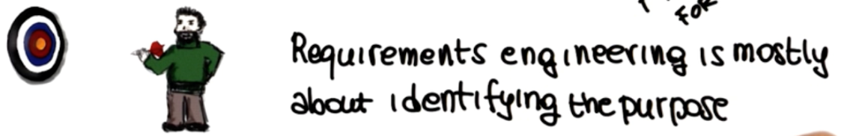

**Software Intensive Systems**

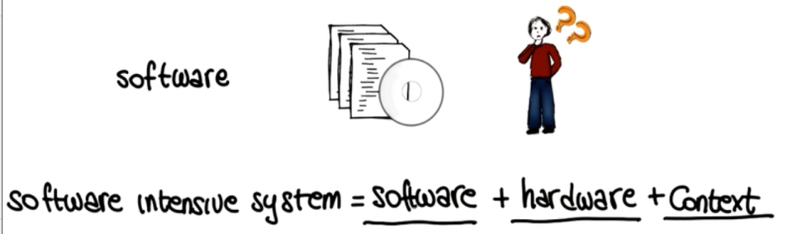

**Software Quality:**



**Identifying Purpose = Defining Requirements**

* Sheer complexity of the purpose / requirements
* Often, people don’t know what they want until you show it to them
* Changing requirements
* Multiple stakeholders with conflicting requirements

**Consider an information system for a Team. In the list below mark all the requirements that you believe are pertinent.**

* Member of the team shall be able to success their training programs.
* The system shall be able to read member cards
* The system shall be able to store members commute time.
* Personal trainers shall be able to add clients
* The list of member shall be stored as a link list

**Why can irrelvalent requirement be harmful.**

* They may lead to missing functionality in the final product
* They can introduce inconsistency
* They can waste project resources
* They may introduce bugs in the software system.
* Requirement Engineering (RE) is a set of activities concerned with identifying and communicating the purpose of a software-intensive system, and the context in which it will be used.
* Hence, RE acts as the bridge between the real-world needs of users, customers, and other constituencies affected by a software system, and the capabilities and opportunities afforded by software-intensive technologies

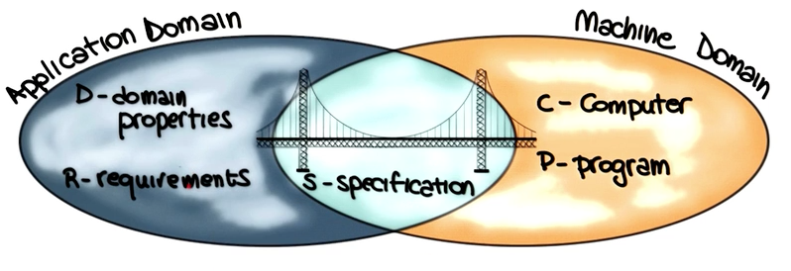

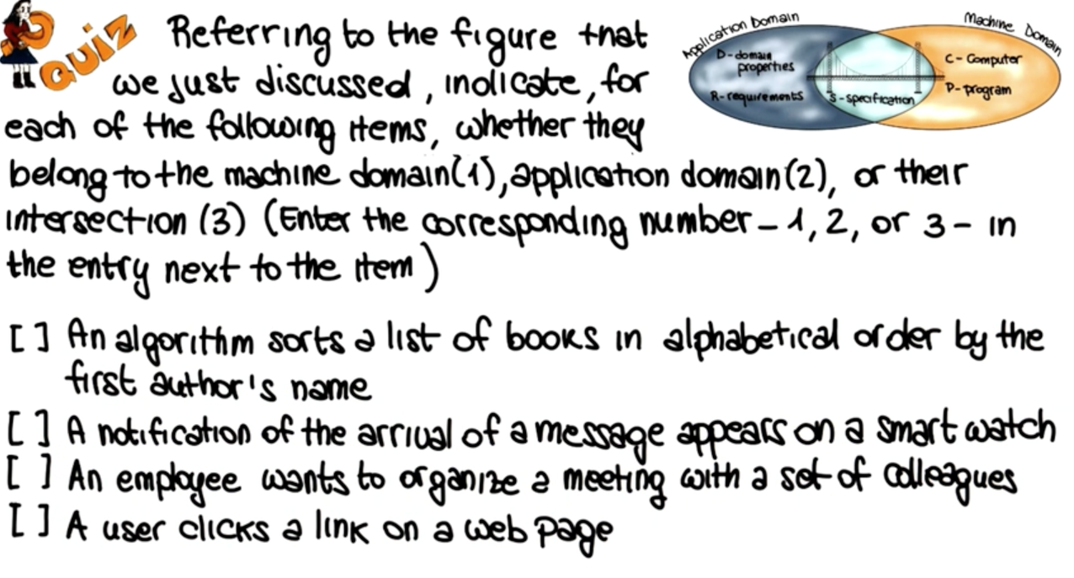

Functional and Non-Functional Requirements

User and System Requirements

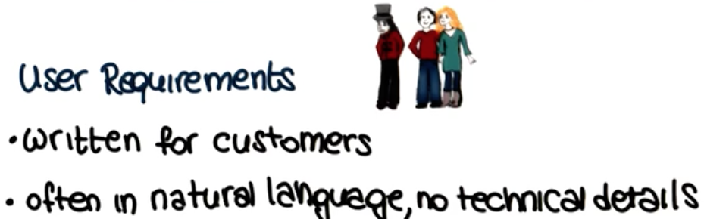

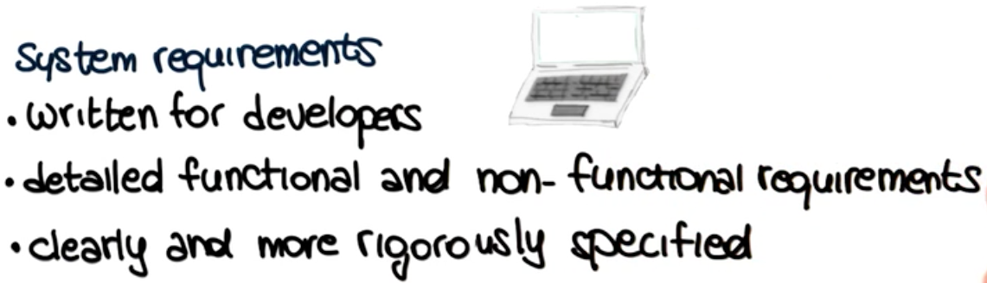

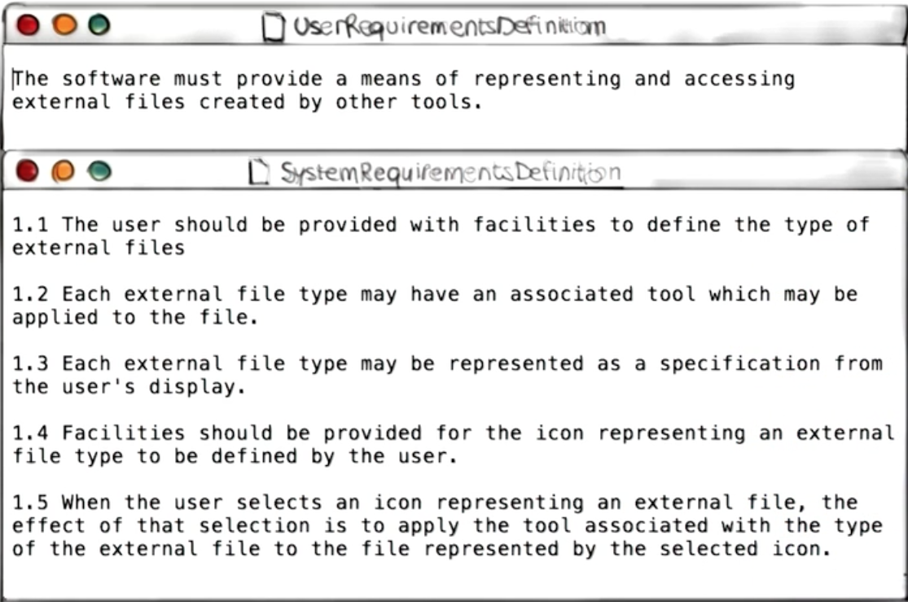

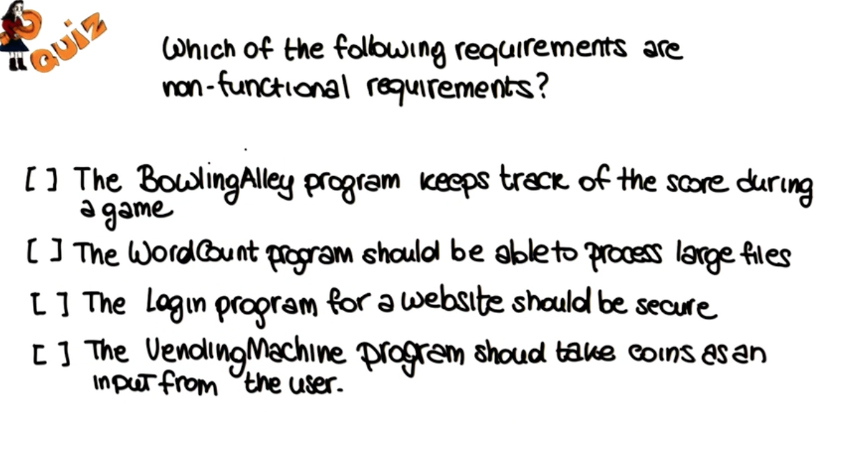



* Stakeholder
* Application domain
* Documentation



* **Thin spread of domain knowledge**
* **Knowledge is tacit**
* **Limited observability**
* **Bias**

**Traditional Techniques:**

* Background reading
* Hard data and samples
* Interviews
* Surveys
* meetings

**Traditional Techniques:**

* Collaborative techniques
* Social approaches
* Cognitive technique

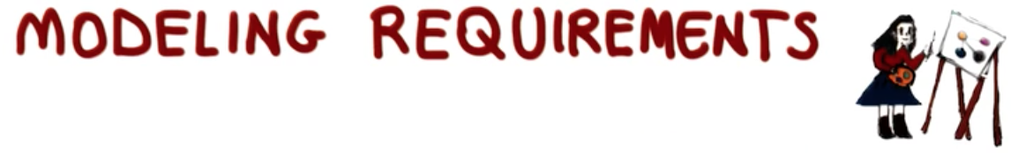

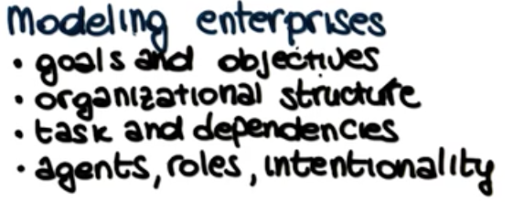

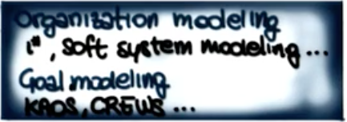

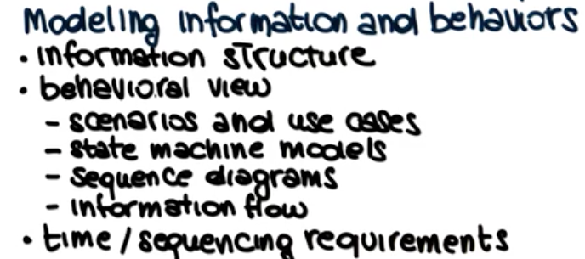

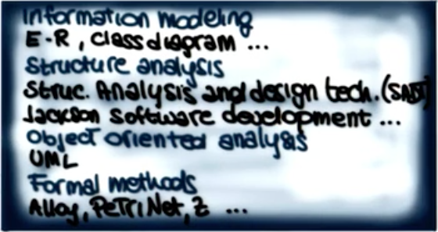



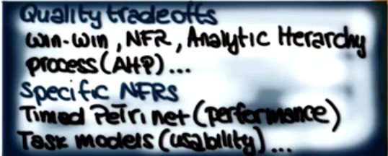



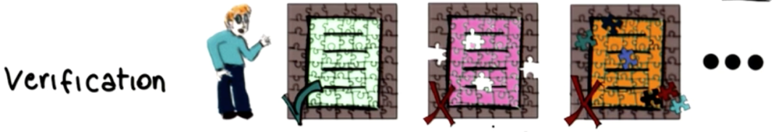

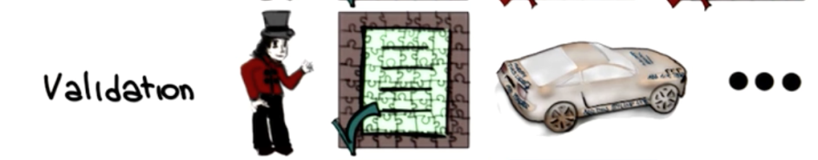

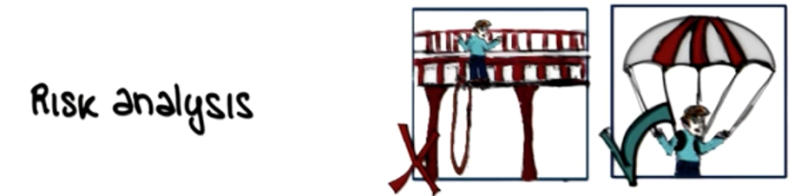

**Requirement Prioritization:**

1. **limiteted resources**
2. **inability to satisfy all the requirmetns**
3. **need to prioritirize**

**mandatory**

**nice to have**

**superfluous**

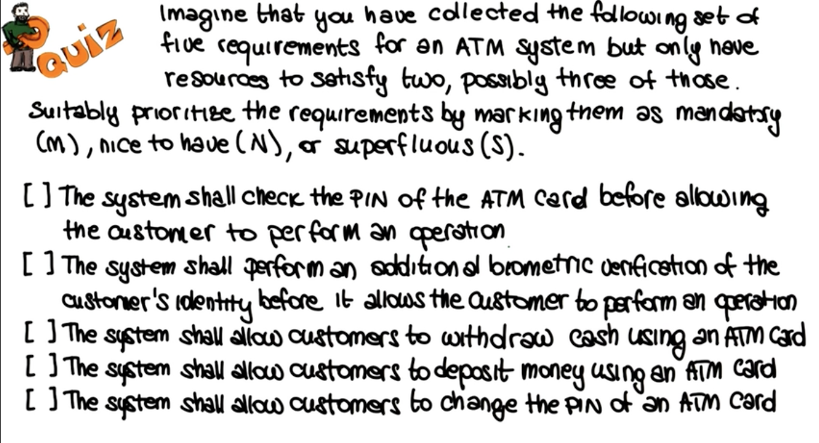

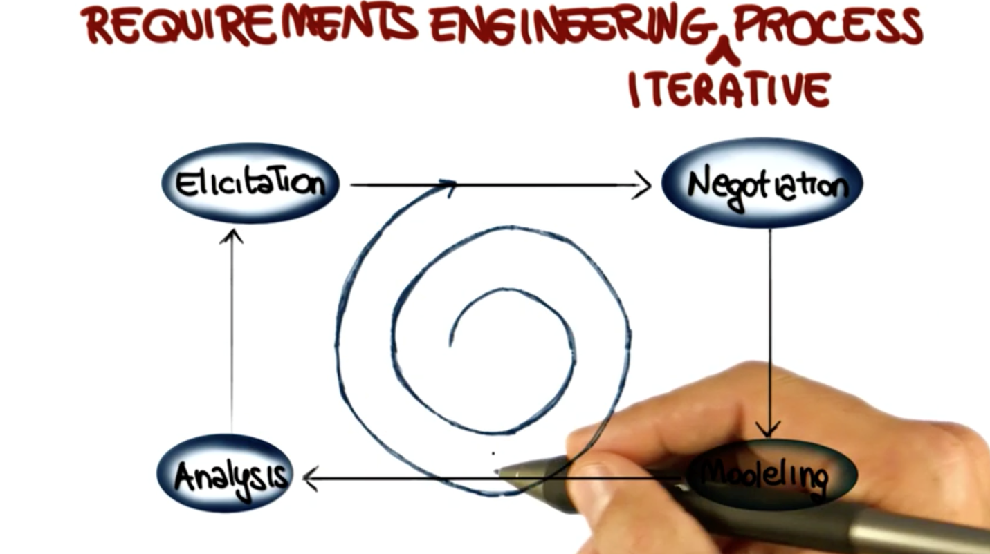

Requirements engineering encompasses seven distinct tasks: **inception, elicitation, elaboration, negotiation, specification, validation, and management.**

**Inception.** How does a software project get started? Is there a single event that becomes the catalyst for a new computer-based system or product, or does the need evolve over time? There are no definitive answers to these questions.

**Elicitation. A**sk the customer, the users, and others what the objectives for the system or product are, what is to be accomplished, how the system or product fits into the needs of the business, and finally, how the system or product is to be used on a day-to-day basis. But it isn’t simple—it’s very hard.

**Elaboration.** The information obtained from the customer during inception and elicitation is expanded and refined during elaboration. This task focuses on developing a refined requirements model (Chapters 9 through 11) that identifies various aspects of software function, behavior, and information.

**Negotiation.** It isn’t unusual for customers and users to ask for more than can be achieved, given limited business resources. It’s also relatively common for different customers or users to propose conflicting requirements, arguing that  
their version is “essential for our special needs.

**Specification.** In the context of computer-based systems (and software), the term *specification* means different things to different people.

**Validation.** The work products produced as a consequence of requirements engineering are assessed for quality during a validation step. Requirements validation examines the specification5 to ensure that all software requirements have  
been stated unambiguously;

**Requirements management.** Requirements for computer-based systems change, and the desire to change requirements persists throughout the life of the system.

**Software Requirements Specification(SRS)**

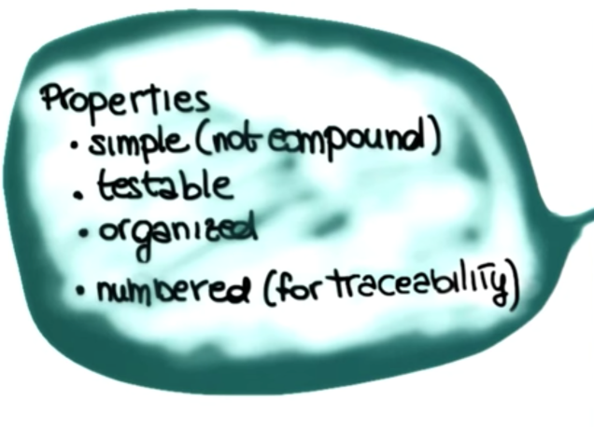

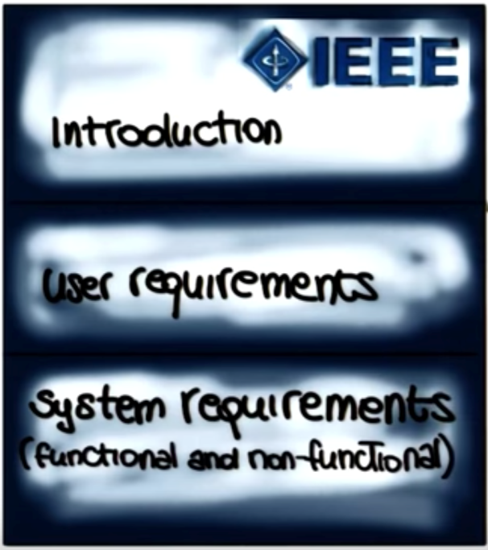

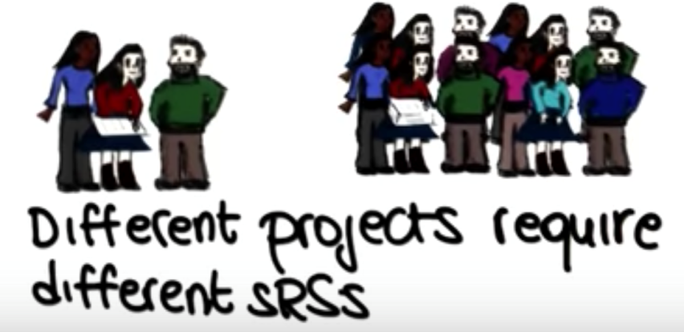

**8.2 Establishing The Groundwork**

**Stakeholders and software engineers work together on the same team.But reality is often quite different. Customer(s) or end users may be located in a different city or country, may have only a vague idea of what is required,** may have conflicting opinions about the system to be built, may have limited technical knowledge.

steps required to establish the groundwork for an understanding of software requirements—to project started in a way that will keep it moving forward toward a successful solution.

**Identifying Stakeholders**

Sommerville and Sawyer [Som97] define a *stakeholder* as “anyone who benefits in a direct or indirect way from the system which is being developed.”

**Recognizing Multiple Viewpoints**

Because many different stakeholders exist, the requirements of the system will be explored from many different points of view.

**Working toward Collaboration** If five stakeholders are involved in a software project, you may have five (or more) different opinions about the proper set of requirements.

**Asking the First Questions**

Questions asked at the inception of the project should be “context free” [Gau89].  
**The first set of context-free questions** focuses on the customer and other stakeholders, the overall project goals and benefits. For example, you might ask:

• Who is behind the request for this work?  
• Who will use the solution?  
• What will be the economic benefit of a successful solution?  
• Is there another source for the solution that you need?

These questions help to identify all stakeholders who will have interest in the software to be built.

**The next set of questions enables** you to gain a better understanding of the problem and allows the customer to voice his or her perceptions about a solution:

• How would you characterize “good” output that would be generated by a successful solution?  
• What problem(s) will this solution address?  
• Can you show me (or describe) the business environment in which the solution will be used?  
• Will special performance issues or constraints affect the way the solution is approached?

**The final set of questions focuses on the effectiveness of the communication** activity itself. Gause and Weinberg [Gau89] call these “meta-questions” and propose the following (abbreviated) list:

• Are you the right person to answer these questions? Are your answers “official”?  
• Are my questions relevant to the problem that you have?  
• Am I asking too many questions?  
• Can anyone else provide additional information?  
• Should I be asking you anything else?

These questions (and others) will help to “break the ice” and initiate the communication that is essential to successful elicitation.

**Nonfunctional Requirements**A nonfunctional requirement(NFR) can be described as a quality attribute, a performance attribute, a security attribute, or a general constraint on a system.

**Traceability**

*Traceability* is a software engineering term that refers to documented links between software engineering work products

**8.3 Eliciting Requirements**

Requirements elicitation (also called *requirements gathering*) combines elements of problem solving, elaboration, negotiation, and specification

**8.3.1 Collaborative Requirements Gathering**

• Meetings (either real or virtual) are conducted and attended by both software engineers and other stakeholders.  
• Rules for preparation and participation are established.  
• An agenda is suggested that is formal enough to cover all important  
points but informal enough to encourage the free flow of ideas.  
• A “facilitator” (can be a customer, a developer, or an outsider) controls the  
meeting.  
• A “definition mechanism” (can be work sheets, flip charts, or wall stickers

**8.3.2 Quality Function Deployment** *Quality function deployment* (QFD) is a quality management technique that translates the needs of the customer into technical requirements for software. QFD “concentrates on maximizing customer satisfaction from the software engineering process”

**8.3.3 Usage Scenarios** As requirements are gathered, an overall vision of system functions and features begin to materialize.

**8.3.4 Elicitation Work Products** The work products produced as a consequence of requirements elicitation will vary depending on the size of the system or product to be built. For most systems,  
the work products include:

(1) a statement of need and feasibility,

(2) a bounded statement of scope for the system or product,

(3) a list of customers, users, and other stakeholders who participated in requirements elicitation,

(4) a description of the system’s technical environment,

(5) a list of requirements (preferably organized by function) and the domain constraints that applies to each,

(6) a set of usage scenarios that provide insight into the use of the system or product  
under different operating conditions, and

(7) any prototypes developed to better define requirements.

**8.3.5 Agile Requirements Elicitation** Within the context of an agile process, requirements are elicited by asking all stakeholders to create *user stories*.

**8.3.6 Service-Oriented Methods** Service-oriented development views a system as an aggregation of services. A *service* can be “as simple as providing a single function, for example, a request/ response-based mechanism that provides a series of random numbers,

**8.4 DEVELOPING USE CASES**

Once actors have been identified, use cases can be developed. Jacobson [Jac92] suggests a number of questions12 that should be answered by a use case:

Who is the primary actor, the secondary actor(s)?  
• What are the actor’s goals?  
• What preconditions should exist before the story begins?  
• What main tasks or functions are performed by the actor?  
• What exceptions might be considered as the story is described?  
• What variations in the actor’s interaction are possible?  
• What system information will the actor acquire, produce, or change?  
• Will the actor have to inform the system about changes in the external  
environment?  
• What information does the actor desire from the system?  
• Does the actor wish to be informed about unexpected changes?

Recalling basic *SafeHome* requirements, we define four actors: **homeowner** (a user), **setup manager** (likely the same person as **homeowner,** but playing a different role), **sensors** (devices attached to the system), and the **monitoring and response subsystem** (the central station that monitors the *SafeHome* home security function). For the purposes of this example, we consider only the **homeowner** actor. The **homeowner** actor interacts with the home security function in  
a number of different ways using either the alarm control panel or a PC.

The homeowner (1) enters a password to allow all other interactions,

(2) inquires about the status of a security zone,

(3) inquires about the status of a sensor,  
(4) presses the panic button in an emergency, and

(5) activates/deactivates the security system

**Use case: InitiateMonitoring**

Primary actor: Homeowner.

Goal in context: To set the system **to monitor sensors when the homeowner** leaves the house or remains inside.

Preconditions: System has been programmed for a password and to recognize various sensors.

Trigger: The homeowner decides to “set” the system, that is, to turn on the alarm functions.

**Scenario:**

1. Homeowner: observes control panel

2. Homeowner: enters password

3. Homeowner: selects “stay” or “away”

4. Homeowner: observes read alarm light to indicate that SafeHome has been armed

**Exceptions:**

1. Control panel is not ready: homeowner checks all sensors to determine which are

open; closes them.

2. Password is incorrect (control panel beeps once): homeowner reenters correct

**password.**

3. Password not recognized: monitoring and response subsystem must be contacted to reprogram password.

4. Stay is selected: control panel beeps twice and a stay light is lit; perimeter sensors are activated.

5. Away is selected: control panel beeps three times and an away light is lit; all sensors are activated.

**Priority:** Essential, must be implemented

**When available:** First increment

**Frequency of use:** Many times per day

**Channel to actor:** Via control panel interface

**Secondary actors:** Support technician, sensors

Channels to secondary actors:

Support technician: phone line

Sensors: hardwired and radio frequency interfaces

**Open issues:**

1. Should there be a way to activate the system without the use of a password or with

an abbreviated password?

2. Should the control panel display additional text messages?

3. How much time does the homeowner have to enter the password from the time the

first key is pressed?

1. Is there a way to deactivate the system before it actually activates?

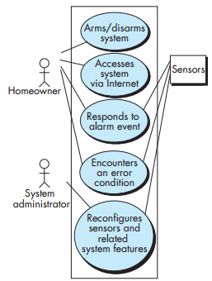Use cases for other homeowner interactions would be developed in a similar manner. It is important to review each use case with care. If some element of the interaction is ambiguous, it is likely that a review of the use case will indicate a problem.

**UML use case  
diagram for  
*SafeHome*home security  
function**

**8.5 BUILDING THE ANALYSIS MODEL**

**8.5.1 Elements of the Analysis Model**

There are many different ways to look at the requirements for a computer-based  
system. Some software people argue that it’s best to select one mode of representation (e.g., the use case) and apply it to the exclusion of all other modes.

* **Scenario-based elements.** The system is described from the user’s point of view using a scenario-based approach. For example, basic use cases (Section 8.4) and their corresponding use case diagrams (Figure 8.2) evolve into more elaborate template-based use cases.
* **Class-based elements.** Each usage scenario implies a set of objects that are manipulated as an actor interacts with the system. These objects are categorized into classes—a collection of things that have similar attributes and common behaviors.
* **Behavioral elements.** The behavior of a computer-based system can have a profound effect on the design that is chosen and the implementation approach that is applied. Therefore, the requirements model must provide modeling elements  
  that depict behavior

**8.5.2 Analysis Patterns**Anyone who has done requirements engineering on more than a few software projects begins to notice that certain problems reoccur across all projects within a specific application domain.18 These *analysis patterns* [Fow97] suggest solutions  
(e.g., a class, a function, a behavior) within the application domain that can be reused when modeling many applications.

**8.5.3 Agile Requirements Engineering**The intent of agile requirements engineering is to transfer ideas from stakeholders to the software team rather than create extensive analysis work products.

**8.5.4 Requirements for Self-Adaptive Systems***Self-adaptive systems*20 can reconfigure themselves, augment their functionality, protect themselves, recover from failure, and accomplish all of this while hiding most of their internal complexity from their users [Qur09]. Adaptive requirements document the variability needed for self-adaptive systems.

**8.6 NEGOTIATING REQUIREMENTS**

Have to enter into a *negotiation* with stakeholders. stakeholders are asked to balance functionality, performance, and other product or system characteristics against cost and time-to-market.

Following activities are defined:  
**1.** Identification of the system or subsystem’s key stakeholders.  
**2.** Determination of the stakeholders’ “win conditions.”  
**3.** Negotiation of the stakeholders’ win conditions to reconcile them into a set of win-win conditions for all concerned (including the software team).

Successful completion of these initial steps achieves a win-win result, which becomes the key criterion for proceeding to subsequent software engineering activities.

**8.7 Requirements Monitoring**Use cases evolve, new test cases are developed for each new software increment, and continuous integration of source code occurs throughout a project.

It encompasses five tasks:

(1) *distributed debugging* uncovers errors and determines their cause,

(2) *run-time verification* determines whether software matches its specification,

(3) *run-time validation* assesses whether the evolving software meets user goals,

(4) *business activity monitoring* evaluates whether a system satisfies business goals, and

(5) *evolution and codesign* provides information to stakeholders as the system evolves.

**8.8 Validating Requirements**

A review of the requirements model addresses the following questions:

• Is each **requirement consistent with the overall objectives for the system or product**?  
• Have **all requirements been specified** at the proper level of abstraction? That is, **do some requirements provide a level of technical** detail that is inappropriate at this stage?

• **Is the requirement really necessary** or does it represent an add-on feature that may not be essential to the objective of the system?  
• Is each requirement bounded and unambiguous?  
• Does each requirement have attribution? That is, is a source (generally, a specific individual) noted for each requirement?  
• Do any requirements conflict with other requirements?  
• Is each requirement achievable in the technical environment that will house the system or product?  
• Is each requirement testable, once implemented?  
• Does the requirements model properly reflect the information, function, and behavior of the system to be built?  
• Has the requirements model been “partitioned” in a way that exposes progressively more detailed information about the system?



**What is Object Orientation?**

1. **Data over function**
2. **Information hiding**
3. **Encapsulation**
4. **Inheritance**

**Objects and Classes:**

1. **Instance varaibles + operator**

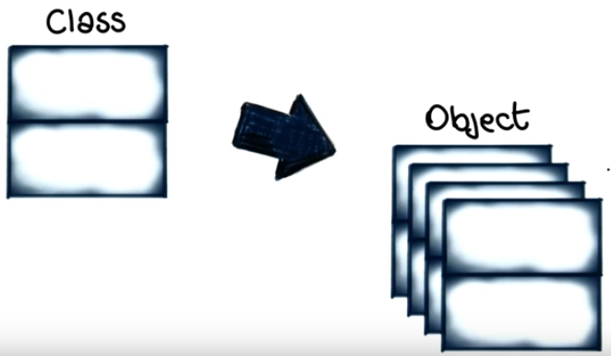

**Why Use OO?**

* **Reduce maintenance costs**
* **Improve development process**
* **Enforce good design**

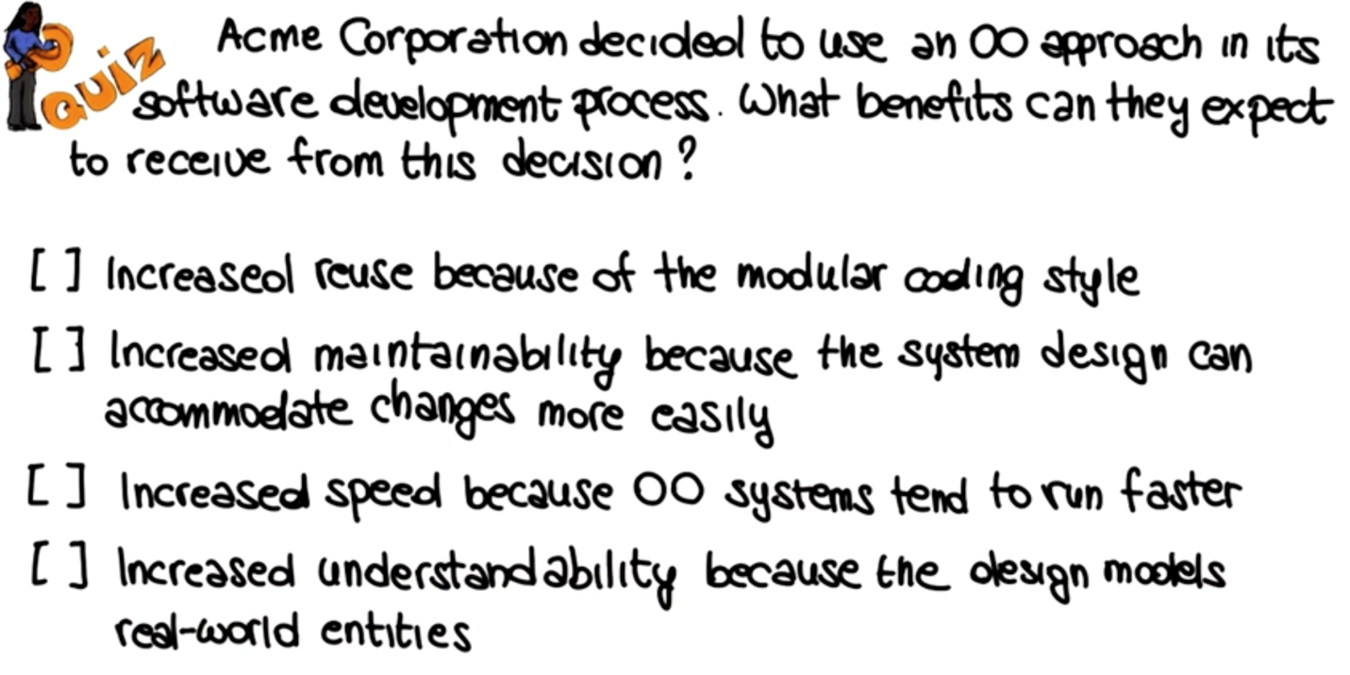

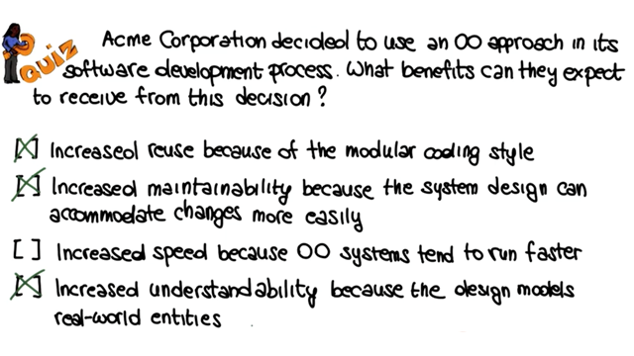

**OOAD: OO Analysis and Design:**

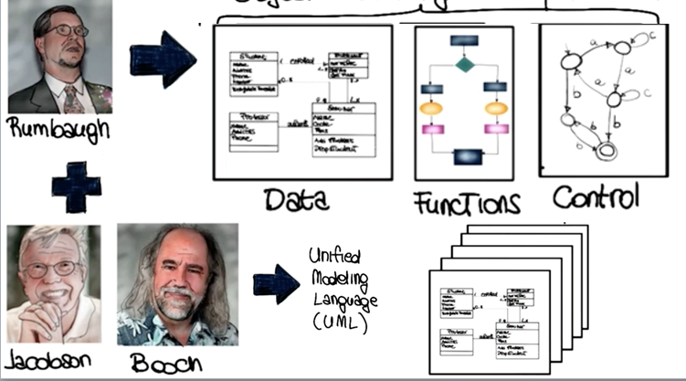

**OO Analysis**

**Functional Oriented = data oriented**

**Real world objects=requirements**

1. **Obtain/prepare textual description of problem**
2. **Underline nouns =>classes**
3. **Underline adjectives=>attributes**
4. **Underline active verlos=> operations**

**10.REQUIREMENTS MODELING:1CLASS-BASED METHODS**

class-based meth- ods for requirements modeling were often categorized as *object oriented analysis.* Although a number of different class-based *object*methods and representations were introduced,

**10.1 IDENTIFYING ANALYSIS CLASSES**

*External entities* (e.g., other systems, devices, people) that produce or consume information to be used by a computer-based system.

• *Things* (e.g., reports, displays, letters, signals) that are part of the information domain for the problem.  
• *Occurrences or events* (e.g., a property transfer or the completion of a series  
of robot movements) that occur within the context of system operation.  
• *Roles* (e.g., manager, engineer, salesperson) played by people who interact  
with the system.  
• *Organizational units* (e.g., division, group, team) that are relevant to an  
application.  
• *Places* (e.g., manufacturing floor or loading dock) that establish the context of the problem and the overall function of the system.  
• *Structures* (e.g., sensors, four-wheeled vehicles, or computers) that define a class of objects or related classes of objects

**10.2 SPECIFYING ATTRIBUTES**

*Attributes* describe a class that has been selected for inclusion in the analysis  
model. In essence, it is the attributes that define the class—that clarify what is  
meant by the class in the context of the problem space. For example, if we were  
to build a system that tracks baseball statistics for professional baseball players,  
the attributes of the class **Player** would be quite different than the attributes of  
the same class when it is used in the context of the professional baseball pension  
system.

**10.3 DEFINING OPERATIONS**

• That an *assign()* operation is relevant for the **Sensor** class.  
• That a *program()* operation will be applied to the **System** class.  
• That *arm()* and *disarm()* are operations that apply to **System** class.

* 1. **REQUIREMENTS MODELING: BEHAVIOR, PATTERNS, AND WEB/MOBILE APPS**

**1.1 CREATING A BEHAVIORAL MODEL**

The *behavioral model* indicates how software will respond to external events  
or stimuli. To create the model, you should perform the following steps: (1) evaluate all use cases to fully understand the sequence of interaction within the system, (2) identify events that drive the interaction sequence and understand how  
these events relate to specific objects, (3) create a sequence for each use case,  
(4) build a state diagram for the system, and (5) review the behavioral model to  
verify accuracy and consistency.

**11.2 IDENTIFYING EVENTS WITH THE USE CASE**

**11.3 STATE REPRESENTATIONS**

**11.4 PATTERNS FOR REQUIREMENTS MODELING**

**11.4.1 Discovering Analysis Patterns**The requirements model comprises a wide variety of elements: scenariobased (use cases), class-based (objects and classes), and behavioral (events  
and states). Each of these elements represents the problem from a different  
perspective, and each provides an opportunity to discover patterns that may  
occur throughout an application domain, or by analogy, across different application domains.

**11.4.2 A Requirements Pattern Example: Actuator-Sensor5**One of the requirements of the *SafeHome* security function is the ability to monitory security sensors (e.g., break-in sensors, fire, smoke or CO sensors, water  
sensors). Internet-based extensions to *SafeHome* will require the ability to control the movement (e.g., pan, zoom) of a security camera within a residence. The  
implication—*SafeHome* software must manage various sensors and “actuators”  
(e.g., camera control mechanisms)

**Pattern Name. Actuator-Sensor  
Intent.** Specify various kinds of sensors and actuators in an embedded system.

**otivation.** Embedded systems usually have various kinds of sensors and actuators. These sensors and actuators are all either directly or indirectly connected  
to a control unit. Although many of the sensors and actuators look quite different,  
their behavior is similar enough to structure them into a pattern. The pattern  
shows how to specify the sensors and actuators for a system, including attributes  
and operations. The **Actuator-Sensor** pattern uses a *pull* mechanism (explicit request for information) for **PassiveSensors** and a *push* mechanism (broadcast of  
information) for the **ActiveSensors.  
Constraints**• Each passive sensor must have some method to read sensor input and attributes that represent the sensor value.  
• Each active sensor must have capabilities to broadcast update messages  
when its value changes.  
• Each active sensor should send a *life tick*, a status message issued within  
a specified time frame, to detect malfunctions.  
• Each actuator must have some method to invoke the appropriate response determined by the **ComputingComponent.**• Each sensor and actuator should have a function implemented to check  
its own operation state.  
• Each sensor and actuator should be able to test the validity of the values  
received or sent and set its operation state if the values are outside of the  
specifications.  
**Applicability.** Useful in any system in which multiple sensors and actuators are  
present.  
**Structure.** UML class diagram for the **Actuator-Sensor** pattern is shown in  
Figure 11.3. **Actuator, PassiveSensor,** and **ActiveSensor** are abstract classes and  
denoted in italics. There are four different types of sensors and actuators in this  
pattern. The **Boolean, Integer,** and **Real** classes represent the most common types  
of sensors and actuators. The complex classes are sensors or actuators that use  
values that cannot be easily represented in terms of primitive data types, such as  
a radar device. Nonetheless, these devices should still inherit the interface from  
the abstract classes since they should have basic functionalities such as querying  
the operation states.  
**Behavior.** Figure 11.4 presents a UML sequence diagram for an example of  
the **Actuator-Sensor** pattern as it might be applied for the *SafeHome* function  
that controls the positioning (e.g., pan, zoom) of a security camera.

**Participants.** This section of the patterns description “itemizes the classes/objects that are included in the requirements pattern” [Kon02] and describes the  
responsibilities of each class/object (Figure 11.3). An abbreviated list follows:  
• **PassiveSensor abstract:** Defines an interface for passive sensors.  
• **PassiveBooleanSensor:** Defines passive Boolean sensors.  
• **PassiveIntegerSensor:** Defines passive integer sensors.  
• **PassiveRealSensor:** Defines passive real sensors.  
• **ActiveSensor abstract:** Defines an interface for active sensors.  
• **ActiveBooleanSensor:** Defines active Boolean sensors.  
• **ActiveIntegerSensor:** Defines active integer sensors.  
• **ActiveRealSensor:** Defines active real sensors.  
• **Actuator abstract:** Defines an interface for actuators.  
• **BooleanActuator:** Defines Boolean actuators.  
• **IntegerActuator:** Defines integer actuators.  
• **RealActuator:** Defines real actuators

**Collaborations.** This section describes how objects and classes interact with  
one another and how each carries out its responsibilities.  
• When the **ComputingComponent** needs to update the value of a  
**PassiveSensor,** it queries the sensors, requesting the value by sending the  
appropriate message.  
• **ActiveSensors** are not queried. They initiate the transmission of sensor  
values to the computing unit, using the appropriate method to set the  
value in the **ComputingComponent.** They send a life tick at least once  
during a specified time frame in order to update their timestamps with  
the system clock’s time.





Set-7

CHAPTER 21 Software Quality Assurance

**21.1 BACKGROUND ISSUES**

Quality control and assurance are essential activities for any business that produces products to be used by others. Prior to the twentieth century, quality control was the sole responsibility of the craftsperson who built a product. As time  
passed and mass production techniques became commonplace, quality control became an activity performed by people other than the ones who built the  
product.

The first formal quality assurance and control function was introduced at Bell  
Labs in 1916 and spread rapidly throughout the manufacturing world. During the  
1940s, more formal approaches to quality control were suggested. These relied  
on measurement and continuous process improvement [Dem86] as key elements  
of quality management

**21.2 ELEMENTS OF SOFTWARE QUALITY ASSURANCE**

Software quality assurance encompasses a broad range of concerns and activities that focus on the management of software quality. These can be summarized  
in the following manner [Hor03]:

**Standards.** The IEEE, ISO, and other standards organizations have produced a broad array of software engineering standards and related documents. Standards may be adopted voluntarily by a software engineering organization or imposed by the customer or other stakeholders. The job of SQA is to ensure that standards that have been adopted are followed and that all work products conform to them.

**Reviews and audits.** Technical reviews are a quality control activity performed by software engineers for software engineers (Chapter 20). Their intent is to uncover errors. Audits are a type of review performed by SQA personnel with the intent of ensuring that quality guidelines are being followed for software engineering work. For example, an audit of the  
review process might be conducted to ensure that reviews are being performed in a manner that will lead to the highest likelihood of uncovering errors.  
**Testing.** Software testing (Chapters 22 through 26) is a quality control function that has one primary goal—to find errors. The job of SQA is to ensure that testing is properly planned and efficiently conducted so that it has the highest likelihood of achieving its primary goal.  
**Error/defect collection and analysis.** The only way to improve is to measure how you’re doing. SQA collects and analyzes error and defect data to

**Change management.** Change is one of the most disruptive aspects of any software project. If it is not properly managed, change can lead to confusion, and confusion almost always leads to poor quality. SQA ensures that adequate change management practices (Chapter 29) have been  
instituted.  
**Education.** Every software organization wants to improve its software engineering practices. A key contributor to improvement is education of software engineers, their managers, and other stakeholders. The SQA  
organization takes the lead in software process improvement (Chapter 37) and is a key proponent and sponsor of educational programs.  
**Vendor management.** Three categories of software are acquired from external software vendors—*shrink-wrapped packages* (e.g., Microsoft Office), a *tailored shell* [Hor03] that provides a basic skeletal structure that is  
custom tailored to the needs of a purchaser, and *contracted software* that  
is custom designed and constructed from specifications provided by the  
customer organization. The job of the SQA organization is to ensure that  
high-quality software results by suggesting specific quality practices that  
the vendor should follow (when possible), and incorporating quality mandates as part of any contract with an external vendor.  
**Security management.** With the increase in cyber crime and new government regulations regarding privacy, every software organization should institute policies that protect data at all levels, establish firewall protection for WebApps, and ensure that software has not been tampered with internally. SQA ensures that appropriate process and technology are used  
to achieve software security (Chapter 27).

**Safety.** Because software is almost always a pivotal component of human-rated systems (e.g., automotive or aircraft applications), the impact of hidden defects can be catastrophic. SQA may be responsible for assessing the impact of software failure and for initiating those stepsrequired to reduce risk.  
**Risk management.** Although the analysis and mitigation of risk (Chapter 35) is the concern of software engineers, the SQA organization ensures that risk management activities are properly conducted and that risk-related contingency plans have been established.

**21.3 SQA PROCESSES AND PRODUCT CHARACTERISTICS**

As we begin a discussion of software quality assurance, it’s important to note that SQA procedures and approaches that work in one software environment may not work as well in another. Even within a company that adopts a consistent approach2 to software engineering, different software products may exhibit different levels of quality

**21.4 SQA TASKS, GOALS, AND METRICS**

Software quality assurance is composed of a variety of tasks associated with two different constituencies—the software engineers who do technical work and an SQA group that has responsibility for quality assurance planning, oversight,  
record keeping, analysis, and reporting.  
Software engineers address quality (and perform quality control activities) by  
applying solid technical methods and measures, conducting technical reviews,  
and performing well-planned software testing.  
**21.4.1 SQA Tasks**The charter of the SQA group is to assist the software team in achieving a  
high-quality end product. The Software Engineering Institute recommends a  
set of SQA activities that address quality assurance planning, oversight, record  
keeping, analysis, and reporting. These activities are performed (or facilitated)  
by an independent SQA group that:  
**Prepares an SQA plan for a project.** The plan is developed as part of project  
planning and is reviewed by all stakeholders. Quality assurance activities  
performed by the software engineering team and the SQA group are governed by the plan. The plan identifies evaluations to be performed, audits and  
reviews to be conducted, standards that are applicable to the project, procedures for error reporting and tracking, work products that are produced by  
the SQA group, and feedback that will be provided to the software team.  
**Participates in the development of the project’s software process  
description.** The software team selects a process for the work to be performed. The SQA group reviews the process description for compliance  
with organizational policy, internal software standards, externally imposed  
standards (e.g., ISO-9001), and other parts of the software project plan.  
**Reviews software engineering activities to verify compliance with the  
defined software process.** The SQA group identifies, documents, and tracks  
deviations from the process and verifies that corrections have been made.  
**Audits designated software work products to verify compliance with those  
defined as part of the software process.** The SQA group reviews selected  
work products; identifies, documents, and tracks deviations; verifies that  
corrections have been made; and periodically reports the results of its  
work to the project manager.  
**Ensures that deviations in software work and work products are documented and handled according to a documented procedure.** Deviations  
may be encountered in the project plan, process description, applicable  
standards, or software engineering work products.  
**Records any noncompliance and reports to senior management.**Noncompliance items are tracked until they are resolved

**21.4.2 Goals, Attributes, and Metrics**The SQA activities described in the preceding section are performed to achieve  
a set of pragmatic goals:  
**Requirements quality.** The correctness, completeness, and consistency  
of the requirements model will have a strong influence on the quality of all  
work products that follow. SQA must ensure that the software team has  
properly reviewed the requirements model to achieve a high level of quality.  
**Design quality.** Every element of the design model should be assessed  
by the software team to ensure that it exhibits high quality and that the  
design itself conforms to requirements. SQA looks for attributes of the design that are indicators of quality.  
**Code quality.** Source code and related work products (e.g., other descriptive information) must conform to local coding standards and exhibit  
characteristics that will facilitate maintainability. SQA should isolate  
those attributes that allow a reasonable analysis of the quality of code.  
**Quality control effectiveness.** A software team should apply limited resources in a way that has the highest likelihood of achieving a high-quality

**21.5 FORMAL APPROACHES TO SQA**

In the preceding sections, we have argued that software quality is everyone’s  
job and that it can be achieved through competent software engineering practice as well as through the application of technical reviews, a multi-tiered testing strategy, better control of software work products and the changes made  
to them, and the application of accepted software engineering standards and  
process frameworks. In addition, quality can be defined in terms of a broad  
array of quality attributes and measured (indirectly) using a variety of indices  
and metrics.  
Over the past three decades, a small, but vocal, segment of the software engineering community has argued that a more formal approach to software quality  
assurance is required.

**21.6 STATISTICAL SOFTWARE QUALITY ASSURANCE**

**1.** Information about software errors and defects is collected and  
categorized.  
**2.** An attempt is made to trace each error and defect to its underlying cause  
(e.g., nonconformance to specifications, design error, violation of standards, poor communication with the customer).  
**3.** Using the Pareto principle (80 percent of the defects can be traced to  
20 percent of all possible causes), isolate the 20 percent (the *vital few*).  
**4.** Once the vital few causes have been identified, move to correct the problems that have caused the errors and defects

**21.6.1 A Generic Example**

• Incomplete or erroneous specifications (IES).  
• Misinterpretation of customer communication (MCC).  
• Intentional deviation from specifications (IDS).  
• Violation of programming standards (VPS).  
• Error in data representation (EDR).  
• Inconsistent component interface (ICI).  
• Error in design logic (EDL).  
• Incomplete or erroneous testing (IET).  
• Inaccurate or incomplete documentation (IID).  
• Error in programming language translation of design (PLT).  
• Ambiguous or inconsistent human/computer interface (HCI).  
• Miscellaneous (MIS).

**21.6.2 Six Sigma for Software Engineering**

The Six Sigma methodology defines three core steps:  
• *Define* customer requirements and deliverables and project goals via  
well-defined methods of customer communication.  
• *Measure* the existing process and its output to determine current quality  
performance (collect defect metrics).  
• *Analyze* defect metrics and determine the vital few causes.  
If an existing software process is in place, but improvement is required, Six  
Sigma suggests two additional steps:  
• *Improve* the process by eliminating the root causes of defects.  
• *Control* the process to ensure that future work does not reintroduce the  
causes of defects.  
These core and additional steps are sometimes referred to as the DMAIC (define, measure, analyze, improve, and control) method.  
If an organization is developing a software process (rather than improving an  
existing process), the core steps are augmented as follows:  
• *Design* the process to (1) avoid the root causes of defects and (2) to meet  
customer requirements

• *Verify* that the process model will, in fact, avoid defects and meet customer requirements.  
This variation is sometimes called the DMADV (define, measure, analyze, design,  
and verify) method

**21.7 SOFTWARE RELIABILITY**

There is no doubt that the reliability of a computer program is an important element of its overall quality. If a program repeatedly and frequently fails to perform, it matters little whether other software quality factors are acceptable.  
Software reliability, unlike many other quality factors, can be measured directly and estimated using historical and developmental data. *Software reliability* is defined in statistical terms as “the probability of failure-free operation of a  
computer program in a specified environment for a specified time

**21.7.1 Measures of Reliability and Availability**Early work in software reliability attempted to extrapolate the mathematics of hardware reliability theory to the prediction of software reliability. Most hardware-related  
reliability models are predicated on failure due to wear rather than failure due to design defects.

**21.7.2 Software Safety***Software safety* is a software quality assurance activity that focuses on the identification and assessment of potential hazards that may affect software negatively  
and cause an entire system to fail.

**CHAPTER 22 Software Testing Strategies**

**Testing Overview and Black-Box Testing Techniques**Software testing is an important technique for assessing the quality of a software product

* the basics of software testing, a verification and validation practice, throughout  
  the entire software development lifecycle
* the two basic techniques of software testing, black-box testing and white-box  
  testing
* six types of testing that involve both black- and white-box techniques.
* strategies for writing fewer test cases and still finding as many faults as possible
* using a template for writing repeatable, defined test cases

**Software Testing: It is a process used to identify the correctness, completeness, quality of developed computer software.**

*Software testing* is the *process of analyzing a software item to detect the differences between existing and required conditions (that is, bugs) and to evaluate the features of the software item* [9, 12]. Software testing is an activity that should be done throughout the whole development process [3].

Software testing is one of the “verification and validation or V&V

It is also help to identify errors, goals or missing requirements.

It can be done either manually or using some software tools.

**22.1.1 Verification and Validation**

**Verification:** “Does the product meet its specifications?”

The set of activities that ensure that S/W correctly implements a specific function and algorithm.

**Verification: Are we building the product right?**Through verification, we make sure the product behaves the way we want it to. For  
example, on the left in Figure 1, there was a problem because the specification said that  
players should collect $200 if they land on or pass Go. Apparently a programmer  
implemented this requirement as if the player had to pass Go to collect. A test case in  
which the player landed on Go revealed this error.

“Are we building the product right?”  
**Validation:** “Does the product performs as desired?”

The set of activities that ensure that the S/W has been built is traceable to customer requirements.

**Validation: Are we building the right product?**Through validation, we check to make sure that somewhere in the process a mistake  
hasn’t been made such that the product build is not what the customer asked for;  
validation always involves comparison against requirements. For example, on the right  
in Figure 1, the customer specified requirements for the Monopoly game – but the  
programmer delivered the game of Life.

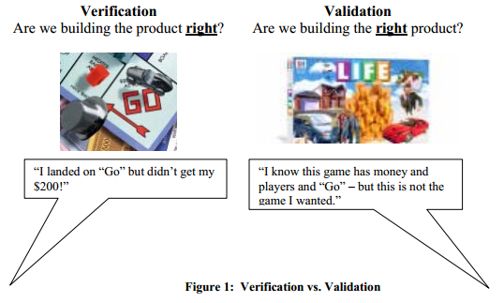

* 1. ***The Economics of Software Testing***

In software development, there are costs associated with testing our programs. We need to write out test plan and our test cases, we need to set up the proper equipment, we need to systematically execute the test cases, we need to follow up on problems that are identified, and we need to remove most of the faults we find. Actually, sometimes we can find low-priority faults in our code and decide that it is too expensive to fix the fault because of the need to redesign, recode, or otherwise remove the fault. These faults can   
remain latent in the product through a follow-on release or perhaps forever. For faults that are not discovered and removed before the software has been shipped, there are costs. Some of these costs are monetary, and some could be significant in less tangible ways. Customers can lose faith in our business and can get very angry. They can also lose a great deal of money if their system goes down because of our defects. (Think of the effect on a grocery store that can’t check out the shoppers because of its “down”  
point-of-sale system.)

* 1. ***The Basics of Software Testing***

There are two basic classes of software testing, black box testing and white box testing.

**BLACK-BOX TESTING:**

* **Black box testing** (also called functional testing) is testing that ignores the internal mechanism of a system or component and focuses solely on the outputs generated in response to selected inputs and execution conditions.
* It is a method of s/w testing that examines the functionality of an application without looking into its internal structures or workings.
* This method is applied at every level of s/w testing:
* Unit(smallest module) testing, integration testing, system and acceptance .
* Tests are based on requirements and functionality. Depends only code:

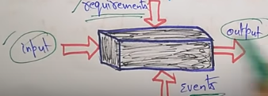

It si carried out to test functionality of the program also called as Behavioural testing

The test in this case:

Has a set of input values and desired results.

On providing input, if the output matches with desired results, the program is tested ok.

In this testing method, the design and structures of code are not know to tester and testing engineers and end uses conduct this test on software.

**White Box Testing:**

* **White box testing** (also called structural testing and glass box testing) is testing that takes into account the internal mechanism of a system or component
* Testing is based on an analysis of the internal structure of complements of system.
* White box testing also known as clear box testing, glass box testing, transparent box testing and structured based testing.
* It can be applied at all levels of SDLC.
* Most detects are found in unit, component and integration levels is through white box.
* Tests are based on coverage of code statement, branches ,paths, conditions.

The classes of testing are denoted by colors to depict the opacity of the testers of the code.  
With *black box testing*, the software tester does not (or should not) have access to the  
source code itself.

The code is considered to be a “big black box” to the tester who can’t  
see inside the box.

The tester knows only that information can be input into to the black box, and the black box will send something back out. Based on the requirements knowledge, the tester knows what to expect the black box to send out and tests to make sure the black box sends out what it’s supposed to send out. Alternatively, *white box testing* focuses on the internal structure of the software code. The white box tester (most   
often the developer of the code) knows what the code looks like and writes test cases by executing methods with certain parameters. In the language of V&V, black box testing is often used for validation (are we building the right software?) and white box testing is often used for verification (are we building the software right?). This chapter focuses on black box testing.

**Dynamic Testing:**

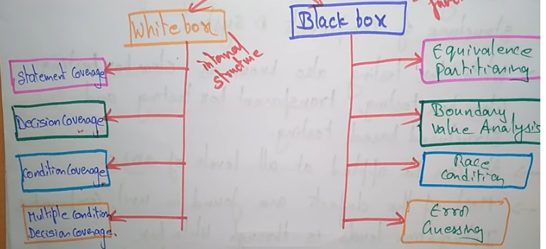

***1.4 Six Types of Testing***

Each type of test has a “specification” that defines the correct behavior the test is examining so  
that incorrect behavior (an observed failure) can be identified.

There are two issues to think about in these types of testing – one is the **opacity** of the tester’s view of the code (is it white or black box testing). The other issue is **scale** (is the tester examining a small bit of code or the whole system and its environment).

1. **Unit Testing**  
   **Opacity:** White box testing  
   Specification: Low-level design and/or code structure  
   *Unit testing* is the *testing of individual hardware or software units or groups of related  
   units* [11].

Using white box testing techniques, testers (usually the developers creating the code implementation) verify that the code does what it is intended to do at a very low   
structural level. For example, the tester will write some test code that will call a method  
with certain parameters and will ensure that the return value of this method is as expected.  
Looking at the code itself, the tester might notice that there is a branch (an if-then) and  
might write a second test case to go down the path not executed by the first test case.

1. **Integration testing**  
   **Opacity:** Black- and white-box testing  
   Specification: Low- and high-level design  
   *Integration test* is *testing in which software components, hardware components, or both  
   are combined and tested to evaluate the interaction between them* [11]*.*

Using both black and white box testing techniques, the tester (still usually the software developer) verifies that units work together when they are integrated into a larger code base. Just because the components work individually, that doesn’t mean that they all work together when assembled or integrated.

For example, data might get lost across an interface, messages might not get passed properly, or interfaces might not be implemented as specified. To plan these integration test cases, testers look at high- and low-level design documents

1. **Functional and system testing**  
   **Opacity**: Black-box testing  
   Specification: high-level design, requirements specification

Using black box testing techniques, testers examine the high-level design and the  
customer requirements specification to plan the test cases to ensure the code does what it  
is intended to do. *Functional testing* involves ensuring that the functionality specified in  
the requirement specification works. System testing involves putting the new program in  
many different environments to ensure the program works in typical customer  
environments with various versions and types of operating systems and/or applications.  
*System testing* is *testing conducted on a complete, integrated system to evaluate the  
system compliance with its specified requirements*

1. **Acceptance testing**  
   **Opacity:** Black-box testing  
   Specification: requirements specification  
   After functional and system testing, the product is delivered to a customer and the customer runs black box acceptance tests based on their expectations of the functionality.

A*cceptance testing* is *formal testing conducted to determine whether or not a system  
satisfies its acceptance criteria (the criteria the system must satisfy to be accepted by a  
customer) and to enable the customer to determine whether or not to accept the system.*

1. **Regression testing**  
   **Opacity:** Black- and white-box testing  
   **Specification:** Any changed documentation, high-level design  
   *Regression testing* is *selective retesting of a system or component to verify that modifications have not caused unintended effects and that the system or component still complies with its specified requirements* [11].

Regression tests are a subset of the original set of test cases. These test cases are re-run often, after any significant changes (bug fixes or enhancements) are made to the code. The purpose of running the regression test case is to make a “spot check” to examine whether the new code works properly and has not damaged any previously-working functionality by propagating unintended side effect.

1. **Beta testing**  
   **Opacity:** Black-box testing  
   **Specification:** None.  
   When an advanced partial or full version of a software package is available, the  
   development organization can offer it free to one or more (and sometimes thousands)  
   potential users or *beta testers*. These users install the software and use it as they wish,  
   with the understanding that they will report any errors revealed during usage back to the  
   development organization. These users are usually chosen because they are experienced  
   users of prior versions or competitive products. The advantages of running beta tests are  
   as follows [8]:  
   • *Identification of unexpected errors* because the beta testers use the software in  
   unexpected ways.  
   • *A wider population search for errors* in a variety of environments (different  
   operating systems with a variety of service releases and with a multitude of other  
   applications running).  
   • *Low costs* because the beta testers generally get free software but are not  
   compensated.  
   The disadvantages of beta testing are as follows [8]:  
   • *Lack of systematic testing* because each user uses the product in any manner they  
   choose.  
   • *Low quality error reports* because the users may not actually report errors or may  
   report errors without enough detail.  
   • *Much effort is necessary to examine error reports* particularly when there are  
   many beta testers.

|  |  |  |  |  |
| --- | --- | --- | --- | --- |
| Testing Type | Specification | General Scope | Opacity | Who generally |
| Unit | Low-Level Design Actual Code Structure | Small unit of  code no larger  than a class | White Box | Programmer  who wrote  code |
| Integration | Low-Level Design  High-Level Design | Multiple classes | White Box  Black Box | Programmers who wrote code |
| Functional | High Level Design | Whole product | Black Box | Independent  tester |
| System | Requirements Analysis | Whole product in  representative  environments | Black Box | Independent  tester |
| Beta | Ad hoc | Whole product  in customer’s  environment | Black box | Customer |
| Regression | Changed  Documentation  High-Level Design | Any of the  above | Black Box  White Box | Programmer(s)  Or independent  testers |

**22.3 TEST STRATEGIES FOR CONVENTIONAL SOFTWARE 3**

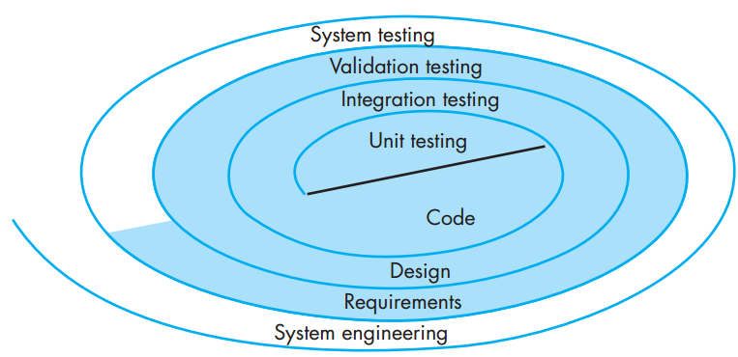

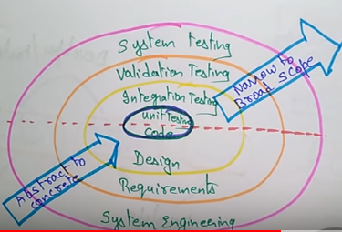

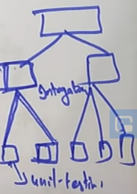

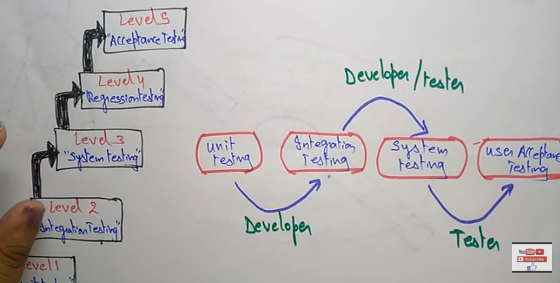

* Unit testing focused on the code to implementing software. Developer
* Next Integration testing focusing on design and construction architecture. Developer /Tester
* Validation focus software requirement analysis Tester
* Finally system testing focusing on whole system. Tester

**1.5 Test Planning:**

Test planning should be done throughout the development cycle.

A *test plan* is a *document describing the scope, approach, resources,  
and schedule of intended test activities. It identifies test items, the features to be tested the testing tasks, who will do each task, and any risks requiring contingency plans.*

A *test case* is a *set  
of test inputs, execution conditions, and expected results developed for a particular  
objective, such as to exercise a particular program path or to verify compliance with a  
specific requirement.*

Write the test plan early in the development cycle when things are generally still going  
pretty smoothly and calmly. This allows you to think through a thorough set of test cases.  
If you wait until the end of the cycle to write and execute test cases, you might be in a  
very chaotic, hurried time period. Often good test cases are not written in this hurried  
environment, and ad hoc testing takes place. With ad hoc testing, people just start trying  
anything they can think of without any rational roadmap through the customer  
requirements. The tests done in this manner are not repeatable

***1.6 Testing as Part of the Development Process:***

It is essential in testing to start planning as soon as the necessary artifact is available. For  
example, as soon as customer requirements analysis has completed, the test team should  
start writing black box test cases against that requirements document. By doing so this  
early, the testers might realize the requirements are not complete. The team may ask  
questions of the customer to clarify the requirements so a specific test case can be written.  
The answer to the question is helpful to the code developer as well. Additionally, the  
tester may request (of the programmer) that the code is designed and developed to allow  
some automated test execution to be done. To summarize, the earlier testing is planned at  
all levels, the better.

It is also very important to consider test planning and test execution as iterative processes.

When requirements change, revise the test cases.

**2. Performing Black Box Testing**

Black box testing, also called *functional testing and behavioral testing*, focuses on  
determining whether or not a program does what it is supposed to do based on its  
functional requirements. Black box testing attempts to find errors in the external  
behavior of the code in the following categories [17]:

(1) incorrect or missing functionality;

(2) interface errors;

(3) errors in data structures used by interfaces;

(4) behavior or performance errors; and

(5) initialization and termination errors.

Through this testing, we can determine if the functions appear to work according to specifications. However, it is important to note that no amount of testing can unequivocally demonstrate the absence of errors and defects in your code.

Through this testing, we can determine if the functions appear to work according to specifications.

It is best if the person who plans and executes black box tests is *not* the programmer of  
the code and does not know anything about the structure of the code. The programmers of the code are innately biased and are likely to test that the program does *what they  
programmed it to do*. What are needed are tests to make sure that the program does *what  
the customer wants it to do*. As a result, most organizations have independent testing  
groups to perform black box testing. These testers are not the developers and are often  
referred to as *third-party* testers. Testers should just be able to understand and specify  
what the desired output should be for a given input into the program, as shown in Figure

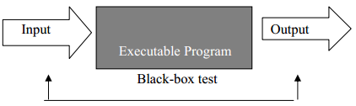

**Figure 3: Black Box Testing. A black-box test takes into account only the input and output of the  
software without regard to the internal code of the program.**

***2.1 The Anatomy of a Test Case***

The format of your test case design is very important. We will use a particular format for  
our test cases, as shown in Table 2. We recommend you use this template in your test  
planning.

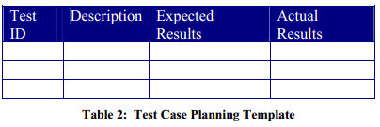

First, you give each test case a unique identifier. When you are tracking large projects,  
you might need to itemize those test cases that have not yet passed. This identifier is  
recorded in the first column.

For example, you might need to say something like, “All my  
test cases are running except playerMovement1. I’m working on that one today.” Next  
in the second column of the table, you specifically describe the set of steps and/or input  
for the particular condition you want to test (including what needs to be done to prepare  
for the test case to be run). The third column is the expected results for an input/output  
oracle – what is expected to come out of the “black box” based upon the input (as  
described in the “description”). An *oracle* is *any program, process, or body of data that  
specified the expected outcome of a set of tests as applied to a tested object* [1]; and  
*input/output oracle* is an *oracle that specifies the expected output for a specified input* [1].  
In the last column, the actual results are recorded after the tests are run. If a test passes,  
the actual results will indicate “Pass.” If a test fails, it is helpful to record “Fail” and a  
description of the failure (“what came out”) in the actual results column.

***2.2 Clear Descriptions:***

It is of prime importance that the test case description be very clear and specific so that  
the test case execution is repeatable. Even if you will always be the person executing the  
test cases, pretend you are passing the test planning document to someone else to perform  
the tests. You need your directions to clear enough for that other person to be able to  
follow the directions explicitly so that the exact same test is executed every time. For  
example, consider a basic test case to ensure that players can move on a Monopoly board.  
Example of poorly specified test case is shown in Table 3:

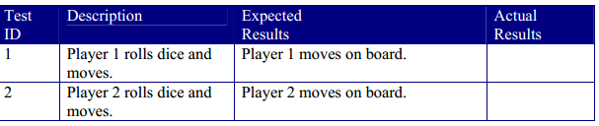

The problem is that the description does not give exact values of how many spaces the  
players moved. This is an overly simplistic problem – but maybe the program crashes  
for some reason when Player 1 and Player 2 land on the same spot. If you don’t  
remember what was actually rolled (you let the rolls be determined randomly and don’t  
record them), you might never be able to cause the problem to happen again because you  
don’t remember the circumstances leading up to the problem. *Recreating the problem* is  
essentially important in testing so that problems that are identified can be repeated and  
corrected. Instead write specific descriptions, such as shown in Table 4.

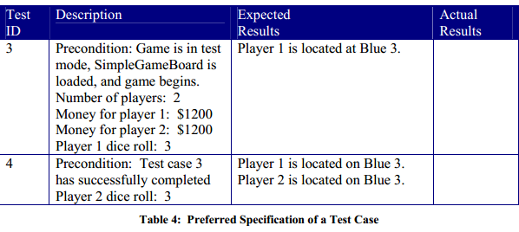

For example, maybe one test case  
(call it Test 11) tests whether a new user can create an ID in a system. Another test case (call it Test 22) may depend upon this new user logging in. Therefore Test 11 must run  
before Test 22 can run. Additionally, if Test 11 fails, than Test 22 cannot be run yet.  
Alternately, perhaps Test 11 passes but Test 22 fails. Later when the functionality is  
fixed, Test 11 must be re-run before the testers try to re-run Test 22. Or, maybe a  
database or the system needs to be re-initialized before a test case can run..

1. **Strategies for Black Box Testing**

Ideally, we’d like to test every possible thing that can be done with our program. But, as  
we said, writing and executing test cases is expensive. We want to make sure that we  
definitely write test cases for the kinds of things that the customer will do most often or  
even fairly often. Our objective is to find as many defects as possible in as few test cases  
as possible.

***3.1 Tests of Customer Requirements***

Black box test cases are based on customer requirements. We begin by looking at each  
customer requirement. To start, we want to make sure that every single customer  
requirement has been tested at least once. As a result, we can trace every requirement to ts test case(s) and every test case back to its stated customer requirement. The first test  
case we’d write for any given requirement is the most-used *success path* for that  
requirement. By success path, we mean that we want to execute *some desirable  
functionality (something the customer wants to work) without any error conditions*. We  
proceed by planning more success path test cases, based on other ways the customer  
wants to use the functionality and some test cases that execute *failure paths*. Intuitively,  
failure paths *intentionally have some kind of errors in them, such as errors that users can  
accidentally input*. We must make sure that the program behaves predictably and  
gracefully in the face of these errors. Finally, we should plan the execution of our tests  
out so that the most troublesome, risky requirements are tested first. This would allow  
more time for fixing problems before delivering the product to the customer. It would be  
devastating to find a critical flaw right before the product is due to be delivered.

**22.1 A STRATEGIC APPROACH TO SOFTWARE TESTING**

* To perform effective testing, you should conduct effective technical reviews
* Testing begins at the component level and works “outward” toward the integration of the entire computer-based system.
* Different testing techniques are appropriate for different software engineering points in time.
* Testing is done by developer of S/W and for large projects an independent test group.
* Testing and debugging are different activities, but debugging must be accommodated in any testing strategy.
* In other words software testing is a verification and validation process:

**White-Box Testing**

*White-box testing* is *testing that takes into account the internal mechanism of a system or  
component* (IEEE, 1990). White-box testing is also known as *structural testing*, *clear box  
testing,* and *glass box testing* (Beizer, 1995). The connotations of “clear box” and “glass  
box” appropriately indicate that you have full visibility of the internal workings of the  
software product, specifically, the logic and the structure of the code.

Using the white-box testing techniques outlined in this chapter, a software engineer can  
design test cases that

(1) exercise independent paths within a module or unit;

(2) exercise logical decisions on both their true and false side;

(3) execute loops at their boundaries and within their operational bounds; and

(4) exercise internal data structures to ensure their validity (Pressman, 2001).

There are six basic types of testing: unit, integration, function/system, acceptance, regression,  
and beta. White-box testing is used for three of these six types:

*Unit testing,* which is *testing of individual hardware or software units or groups of  
related units* (IEEE, 1990). A *unit* is *a software component that cannot be subdivided  
into other components* (IEEE, 1990). Software engineers write white-box test cases to  
examine whether the unit is coded correctly. Unit testing is important for ensuring the  
code is solid before it is integrated with other code. Once the code is integrated into the  
code base, the cause of an observed failure is more difficult to find. Also, since the  
software engineer writes and runs unit tests him or herself, companies often do not track  
the unit test failures that are observed– making these types of defects the most “private”  
to the software engineer. We all prefer to find our own mistakes and to have the  
opportunity to fix them without others knowing. Approximately 65% of all bugs can be  
caught in unit testing (Beizer, 1990).  
• *Integration testing,* which is *testing in which software components, hardware  
components, or both are combined and tested to evaluate the interaction between them*(IEEE, 1990). Test cases are written which explicitly examine the interfaces between  
the various units. These test cases can be black box test cases, whereby the tester  
understands that a test case requires multiple program units to interact. Alternatively,  
white-box test cases are written which explicitly exercise the interfaces that are known  
to the tester.  
• *Regression testing,* which is *selective retesting of a system or component to verify that  
modifications have not caused unintended effects and that the system or component still  
complies with its specified requirements* (IEEE, 1990). As with integration testing,  
regression testing can be done via black-box test cases, white-box test cases, or a  
combination of the two. White-box unit and integration test cases can be saved and rerun as part of regression testing.

**1 White-Box Testing by Stubs and Drivers**

With white-box testing, you must run the code with predetermined input and check to make  
sure that the code produces predetermined outputs.

A *driver* is *a software module used to invoke a module under test and, often, provide test inputs, control and monitor execution, and report test results* (IEEE, 1990) or most simplistically a *line of code that calls a method and passes that method a value*.

For example, if you wanted to move a Player instance,Player1, two spaces on the board, the driver code would be movePlayer(Player1, 2);

This driver code would likely be called from the main method. A white-box test case would  
execute this driver line of code and check Player.getPosition() to make sure the player is  
now on the expected cell on the board.

A *stub* is a *computer program statement substituting for the body of a software module that  
is or will be defined elsewhere* (IEEE, 1990) or a *dummy component or object used to  
simulate the behavior of a real component* (Beizer, 1990) until that component has been  
developed.

For example, if the movePlayer method has not been written yet, a stub such as the one below might be used temporarily – which moves any player to position 1.

public void movePlayer(Player player, int diceValue) {  
player.setPosition(1);  
}

1. **Deriving Test Cases**devising a thorough set of white-box test cases. These methods can serve as guidelines for you as you design test cases. Even  
   though it may seem like a lot of work to use these methods, statistics show [1] that the act of  
   careful, complete, systematic test **design** will catch as many bugs as the act of testing. The  
   test design process, at all levels, is at least as effective at catching bugs as is running the test  
   case designed by that process.  
   Each time you write a code module, you should write test cases for it based on the guidelines. A possible exception to this recommendation is the accessor methods (i.e., getters and setters) of your projects. You should concentrate your testing effort on code that could easily be broken. Generally, accessor methods will be written error-free.

***2.1 Basis Path Testing***

*Basis path testing* (McCabe, 1976) is a means for ensuring that all independent paths through  
a code module have been tested. An *independent path* is any path through the code that  
introduces at least one new set of processing statements or a new condition.

Once you understand basis path testing, it may not be necessary to draw the flowgraph – though you may always find a quick sketch helpful.

A flowgraph of purchasing property appears in Figure 1. The flowgraph is intended to  
depict the following requirement.

*f a player lands on a property owned by other players, he or she needs to pay the  
rent. If the player does not have enough money, he or she is out of the game. If the  
property is not owned by any players, and the player has enough money buying the  
property, he or she may buy the property with the price associated with the property*

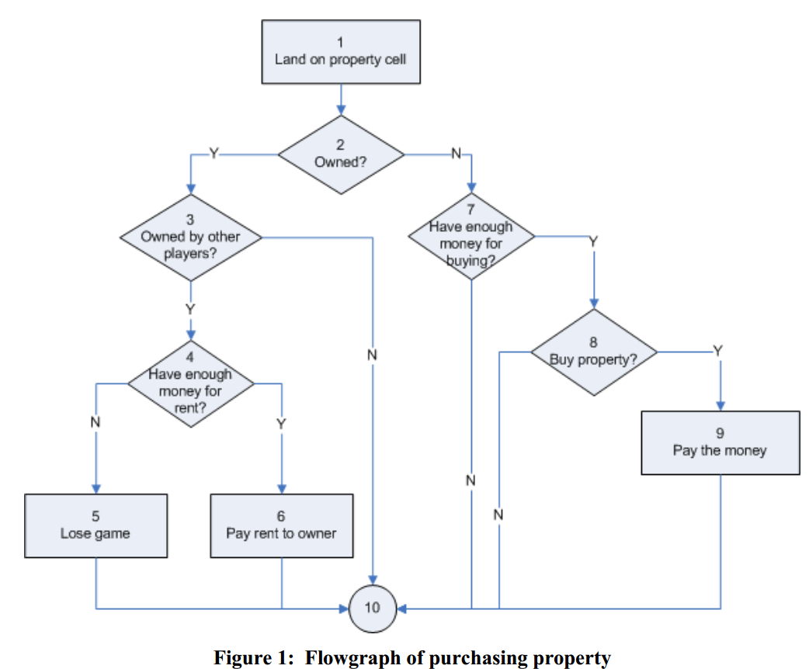

Using this flow graph, we can compute the number of independent paths through the code.  
We do this using a metric called the *cyclomatic number.*

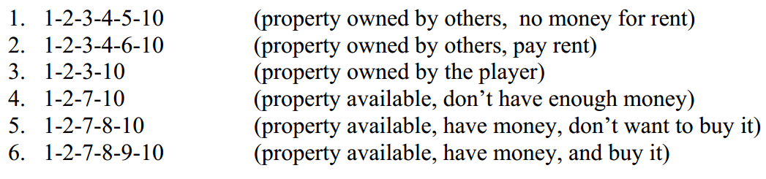

We would want to write a test case to ensure that each of these paths is tested at least once.

***2.2 Equivalence Partitioning/Boundary Value Analysis***

Equivalence partitioning (EP) and boundary value analysis (BVA) provide a strategy for  
writing white-box test cases.

Equivalence partitioning (EP) and boundary value analysis (BVA) provide a strategy for  
writing white-box test cases. For example, a person might  
want to buy a house, but may or may not have enough money.

1. property costs $100, have $200 (equivalence class “have enough money”)  
2. property costs $100, have $50 (equivalence class, “don’t have enough money”)  
3. property costs $100, have $100 (boundary value)  
4. property costs $100, have $99 (boundary value)  
5. property costs $100, have $101 (boundary value)

**3 Control-flow/Coverage Testing**

The *control flow* of the program is represented in a flow graph, as shown in Figure  
1. We consider various aspects of this flowgraph in order to ensure that we have an adequate  
set of test cases. The adequacy of the test cases is often measured with a metric called  
coverage. *Coverage* is a measure of the completeness of the set of test cases. To  
demonstrate the various kinds of coverage, we will use the simple code example shown in  
Figure 2 as a basis of discussion as we take up the next five topics.

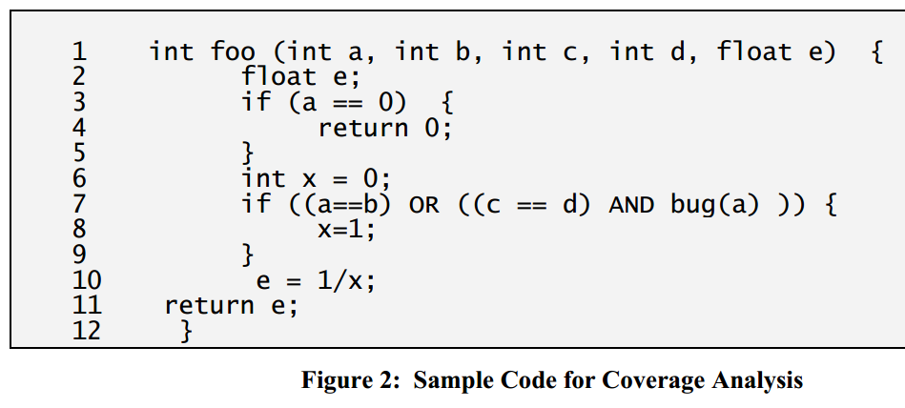

* 1. ***Method Coverage***

*Method coverage* is *a measure of the percentage of methods that have been executed by test  
cases*. Undoubtedly, your tests should call 100% of your methods. It seems irresponsible to  
deliver methods in your product when your testing never used these methods. As a result,  
you need to ensure you have 100% method coverage. In the code shown in Figure 3, we attain 100% method coverage by calling the foo method.  
Consider Test Case 1: the method call **foo(0, 0, 0, 0, 0.)**, expected return value of 0. If you  
look at the code, you see that if a has a value of 0, it doesn’t matter what the values of the  
other parameters are – so we’ll make it really easy and make them all 0.

* 1. ***Statement Coverage***

*Statement coverage* is *a measure of the percentage of statements that have been executed by  
test cases*. Your objective should be to achieve 100% statement coverage through your  
testing. Identifying your cyclomatic number and executing this minimum set of test cases  
will make this statement coverage achievable.

***3.3 Branch Coverage***

*Branch coverage* is *a measure of the percentage of the decision points (Boolean expressions)  
of the program have been evaluated as both true and false in test cases*. The small program  
in Figure 3 has two decision points – one on line 3 and the other on line 7.



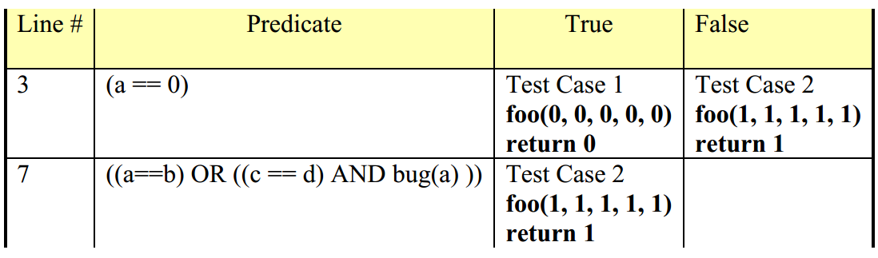

* 1. ***Condition Coverage***

*Condition coverage* is *a  
measure of percentage of Boolean sub-expressions of the program that have been evaluated  
as both true or false outcome [applies to compound predicate] in test cases*. Notice that in  
line 7 there are three sub-Boolean expressions to the larger statement (a==b), (c==d), and  
bug(a). Condition coverage measures the outcome of each of these sub-expressions  
independently of each other. With condition coverage, you ensure that each of these subexpressions has independently been tested as both true and false.

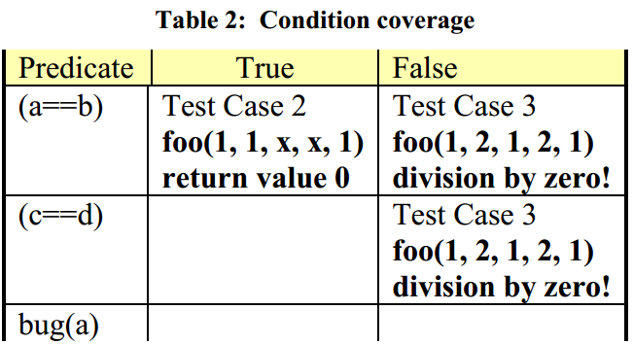

1. **Data Flow Testing**

In data flow-based testing, the control flowgraph is annotated with information about how the program variables are defined and used. Different criteria exercise with varying degrees of precision how a value assigned to a variable is used along different control flow paths. A  
reference notation is a definition-use pair, which is a triple of (d, u, V) such that V is a  
variable, d is a note in which V is defined, and us is a node in which V is used. There exists  
a path between d and u in which the definition of V in d is used in u.

1. **Failure (“Dirty”) Test Cases**

As with black-box test cases, you must think diabolically about the kinds of things users  
might do with your program. Look at the structure of your code and think about every  
possible way a user might break it. These devious ways may not be uncovered by the  
previously mentioned methods for forming test cases.

* Look at every input into the code you are testing. Do you handle each input if it  
  is incorrect, the wrong font, or too large (or too small)?
* Look at code from a security point of view. Can a user overflow a buffer, causing  
  a security problem?
* Look at every calculation. Could it possible create an overflow? Have you  
  protected from possible division by zero?

1. **Flow Graphs Revisited**

The flowgraph of Figure 1 was fairly straightforward because there were no compound  
Boolean predicates. Let’s go back and look at what a flowgraph of the code in Figure 2  
would look like. When you encounter a compound predicate, such as in line 7, you must  
break the expression up so that each Boolean sub-expression is evaluated on its own, as  
shown below in Figure 3.

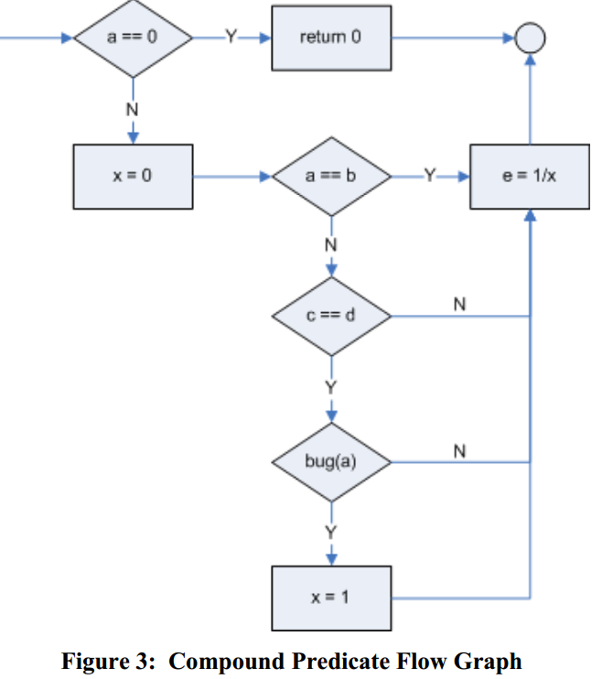

“Are we building the right product?”

**klA strategy for testing conventional software:**

The definition of V&V encompasses many software quality assurance activities  
(Chapter 21).1  
Verification and validation includes a wide array of SQA activities: technical  
reviews, quality and configuration audits, performance monitoring, simulation,  
feasibility study, documentation review, database review, algorithm analysis, development testing, usability testing, qualification testing, acceptance testing, and  
installation testing. Although testing plays an extremely important role in V&V,  
many other activities are also necessary.

**22.1.2 Organizing for Software Testing**For every software project, there is an inherent conflict of interest that occurs  
as testing begins. The people who have built the software are now asked to test  
the software. This seems harmless in itself; after all, who knows the program  
better than its developers? Unfortunately, these same developers have a vested  
interest in demonstrating that the program is error-free, that it works according  
to customer requirements, and that it will be completed on schedule and within  
budget. Each of these interests mitigates against thorough testing

**22.1.3 Software Testing Strategy—The Big Picture**The software process may be viewed as the spiral illustrated in Figure 22.1.  
Initially, system engineering defines the role of software and leads to software  
requirements analysis, where the information domain, function, behavior, performance, constraints, and validation criteria for software are established. Moving inward along the spiral, you come to design and finally to coding.

**22.1.4 Criteria for Completion of Testing**A classic question arises every time software testing is discussed: “When are we  
done testing—how do we know that we’ve tested enough?” Sadly, there is no definitive answer to this question, but there are a few pragmatic responses and  
early attempts at empirical guidance.  
One response to the question is: “You're never done testing; the burden simply  
shifts from you (the software engineer) to the end user.” Every time the user executes a computer program, the program is being tested. This sobering fact underlines the importance of other software quality assurance activities. Another  
response (somewhat cynical but nonetheless accurate) is: “You’re done testing  
when you run out of time or you run out of money.”  
Although few practitioners would argue with these responses, you need more  
rigorous criteria for determining when sufficient testing has been conducted.  
The *cleanroom software engineering* approach (Chapter 28) suggests statistical  
use techniques [Kel00] that execute a series of tests derived from a statistical  
sample of all possible program executions by all users from a targeted population. By collecting metrics during software testing and making use of existing  
statistical models,

**22.2 STRATEGIC ISSUES**Later in this chapter, we present a systematic strategy for software testing. But  
even the best strategy will fail if a series of overriding issues are not addressed.  
Tom Gilb [Gil95] argues that a software testing strategy will succeed only when  
software testers: (1) specify product requirements in a quantifiable manner long  
before testing commences, (2) state testing objectives explicitly, (3) understand  
the users of the software and develop a profile for each user category, (4) develop  
a testing plan that emphasizes “rapid cycle testing,”2 (5) build “robust” software  
that is designed to test itself (the concept of antibugging is discussed in Section  
22.3.1), (6) use effective technical reviews as a filter prior to testing, (7) conduct  
technical reviews to assess the test strategy and test cases themselves, and (8)  
develop a continuous improvement approach.

**22.3.1 Unit Testing** *Unit testing* focuses verification effort on the smallest unit of software design— the software component or module.

* Using the component-level design description as a guide, important control paths are tested to uncover errors within the boundary of the module.
* The relative complexity of tests and the errors those tests uncover is limited by the constrained scope established for unit testing. The unit test focuses on the internal processing logic and data structures within the boundaries of a component.
* This type of testing can be conducted in parallel for multiple components.

**Unit Test Considerations.** Unit tests are illustrated schematically in Figure 22.3.

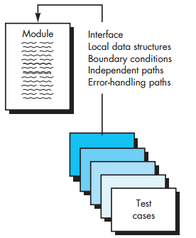The module interface is tested to ensure that information properly flows into and out of the program unit under test.

Local data structures are examined to ensure that data stored temporarily maintains its integrity during all steps in an algorithm’s execution.

**Unit-Test Procedures.** Unit testing is normally considered as an adjunct to the coding step.

* The design of unit tests can occur before coding begins or after source code has been generated.
* A review of design information provides guidance for establishing test cases that are likely to uncover errors in each of the categories discussed earlier.
* Each test case should be coupled with a set of expected results .

**22.3.2 Integration Testing**A neophyte in the software world might ask a seemingly legitimate question once all modules have been unit tested: “If they all work individually, why do you doubt that they’ll work when we put them together?” The problem, of course, is “putting them together”—interfacing.

Data can be lost across an interface; one component can have an inadvertent, adverse effect on another; subfunctions, when combined,

**Top-Down Integration.** *Top-down integration testing* is an incremental approach to construction of the software architecture. Modules are integrated by moving downward through the control hierarchy, beginning with the main control module (main program).

Modules subordinate (and ultimately subordinate) to the main control module are incorporated into the structure in either a depthfirst or breadth-first manner

**1.** The main control module is used as a test driver and stubs are substituted for all components directly subordinate to the main control module.  
**2.** Depending on the integration approach selected (i.e., depth or breadth first), subordinate stubs are replaced one at a time with actual components.  
**3.** Tests are conducted as each component is integrated.  
**4.** On completion of each set of tests, another stub is replaced with the real component

**Bottom-Up Integration.** *Bottom-up integration testing,* as its name implies, begins construction and testing with *atomic modules* (i.e., components at the lowest levels in the program structure). Because components are integrated from the bottom up, the functionality provided by components subordinate to a given level is always available and the need for stubs is eliminated. A bottom-up integration strategy may be implemented with the following steps:  
1. Low-level components are combined into clusters (sometimes called *builds*) that perform a specific software subfunction.  
**2.** A *driver* (a control program for testing) is written to coordinate test-case input and output.  
**3.** The cluster is tested.  
**4.** Drivers are removed and clusters are combined moving upward in the program structure

**Regression Testing.** Each time a new module is added as part of integration testing, the software changes. New data flow paths are established, new I/O may occur, and new control logic is invoked. Side effects associated with these changes may cause problems with functions that previously worked flawlessly. In the context of an integration test strategy, *regression testing* is the reexecution of some subset of tests that have already been conducted to ensure that changes have not propagated unintended side effects. Regression testing helps to ensure that changes (due to testing or for other reasons) do not introduce unintended  
behavior or additional errors

**Smoke Testing.** *Smoke testing* is an integration testing approach that is commonly used when product software is developed. It is designed as a pacing mechanism for time-critical projects, allowing the software team to assess the project on a frequent basis. In essence, the smoke-testing approach encompasses the following activities:   
**1.** Software components that have been translated into code are integrated into a *build.* A build includes all data files, libraries, reusable modules, and engineered components that are required to implement one or more product functions.  
**2.** A series of tests is designed to expose errors that will keep the build from properly performing its function. The intent should be to uncover “show-stopper” errors that have the highest likelihood of throwing the software project behind schedule.  
**3.** The build is integrated with other builds, and the entire product (in its current form) is smoke tested daily. The integration approach may be top down or bottom up.





CHAPTER 31 Project Management Concepts

CHAPTER 33 Estimation for Software Projects

**Create a visual layout that aids understanding**

|  |  |
| --- | --- |
| CHAPTER 3 Software Process Structure  CHAPTER 4 Process Models | Question set 2 |
| CHAPTER 5 Agile Development (Scrum, XP, Lean, Kanban) | Question set 3 |
| CHAPTER 7 Principles That Guide Practice  CHAPTER 8 Understanding Requirements | Question set 4 |
| CHAPTER 10 Requirements Modeling: Class-Based Methods CHAPTER 11 Requirements Modeling: Behavior, Patterns, and Web/Mobile Apps | Question set 5 |
| CHAPTER 12 Design Concepts CHAPTER 13 Architectural Design  CHAPTER 14 Component-Level Design  CHAPTER 15 User Interface Design | Question set 6 |
| CHAPTER 21 Software Quality Assurance  CHAPTER 22 Software Testing Strategies | Question set 7 |
| CHAPTER 31 Project Management Concepts  CHAPTER 33 Estimation for Software Projects | Question set 8 |